CareerCompass: An NLP-Based IT Career Path Recommendation System with E-Portfolio for Bachelor of Science in Information Technology Students of Pamantasan ng Lungsod ng Pasig
A Capstone Project presented to the
College of Computer Studies of
Pamantasan ng Lungsod ng Pasig
In partial fulfillment of the requirements for the degree of
Bachelor of Science in Information Technology
By
Cogal, Daryl Iveen G.
Ramirez, John Gabriel
Salva, Alvin
Presented to:
Rebecca Fajardo
Adviser
October 2026

CHAPTER 1
THE PROBLEM AND ITS BACKGROUND

The Problem and Its Background
In today’s rapidly evolving technological landscape, choosing the right career path has become one of the most critical decisions for students pursuing degrees in Information Technology. The field of IT is expansive, encompassing diverse specializations such as web development, software engineering, network engineering, data analytics, and cybersecurity, among others. As the global demand for skilled IT professionals continues to grow, students are increasingly overwhelmed by the breadth of career options available to them upon graduation.
This uncertainty is not simply a matter of preference; it has measurable consequences. According to the International Labour Organization (2023), the digital economy of the world is growing at an unprecedented rate, with IT-related occupations projected to grow significantly over the next decade. While this expansion creates abundant opportunities for individuals entering the field, it also amplifies the challenge faced by college students in determining which specific career within information technology best aligns with their individual skills, academic performance, certifications, and interests.
Several researchers have responded to this challenge with data-driven career guidance tools. Al-Dossari et al. (2020), for instance, proposed a machine learning-based recommendation system called CareerRec, which uses algorithms to help IT graduates select career paths based on their skills, demonstrating the effectiveness of data-driven approaches in career guidance. Building on this direction, Siswipraptini et al. (2024) developed a personalized career-path recommendation model specifically for Information Technology students in Indonesia, highlighting the relevance and applicability of such systems in an academic setting similar to the Philippine context.
A closely related strand of this work focuses not on structured skill scores but on unstructured evidence — the projects, write-ups, and descriptions students themselves produce. Research on technology-supported career guidance shows that data-driven tools can help students organize evidence about their competencies and explore appropriate career options, and pretrained language models offer a practical way to analyze this kind of unstructured portfolio text. By converting portfolio content and career descriptions into semantic embeddings, a system can compare their meanings rather than relying only on exact keyword matches — an approach that is well suited to a career-guidance system that must interpret the projects, skills, and experiences students describe in their e-portfolios.
It is against this backdrop that the local context of this study takes shape. Pamantasan ng Lungsod ng Pasig (PLP) is a local university located in Pasig City, Metro Manila, Philippines, established primarily to expand access to higher education for qualified residents of Pasig City. Its admission priority notwithstanding, PLP has grown to provide quality, industry-aligned instruction to a broader student population and is recognized across its colleges for producing competitive graduates. Among these, the College of Computer Studies (CCS) offers several computing programs, including the Bachelor of Science in Information Technology (BSIT), which enrolls several hundred students across its four year levels and aims to produce graduates who are competent and globally competitive in the IT industry. Despite the program’s strong curriculum, many BSIT students at PLP currently lack access to a structured and personalized career guidance system specifically designed for Information Technology career planning.
In the absence of such a system, career decisions among BSIT students at PLP are commonly based on personal preference, advice from classmates, or information gathered informally from the internet. While these sources may provide general guidance, they do not objectively evaluate a student’s academic performance, technical skills, certifications, seminars attended, trainings completed, and career interests to determine the most suitable IT career path. Preliminary student feedback gathered by the researchers, together with the literature reviewed above, points to the same conclusion: a data-driven recommendation system, tailored to the BSIT program at PLP, may help students make more informed career decisions based on their competencies and credentials.
Taken together, these observations point to a specific gap that this study addresses. Existing career-recommendation research demonstrates that skill-based and portfolio-based matching can guide IT students effectively, and existing student profile systems demonstrate that e-portfolios can meaningfully document a student’s competencies — yet no such system currently exists for, or is adapted to, the BSIT program of PLP specifically. Without it, BSIT students remain uncertain about which competencies they should further develop to achieve their desired careers, a gap that can result in graduates entering fields that do not fully align with their competencies, leading to career dissatisfaction and reduced professional performance.
This study aims to address this gap through the development of CareerCompass, an NLP-assisted IT career path recommendation system with a student profile and e-portfolio assessment component, designed for BSIT students of Pamantasan ng Lungsod ng Pasig. Students can create accounts, provide their general weighted average (GWA), rate their interest in each of the five IT career tracks, and submit a text-based PDF portfolio or a public e-portfolio website. The system extracts readable portfolio text and uses a pretrained sentence-embedding model to compare it with predefined descriptions of IT career tracks, producing a portfolio similarity score for each track. This portfolio score is then combined with the student’s GWA and interest ratings through a weighted synthesis to produce the final ranked recommendation, together with detected skill evidence. The recommendation can be refreshed when a student submits updated portfolio content, GWA, or interest ratings.
The development of CareerCompass is significant not only for individual students who seek clarity in their career direction, but also for the institution as a whole. By equipping BSIT students with data-driven career insights early in their academic journey, PLP can better prepare its graduates for the demands of the IT industry, improve graduate employability, and strengthen the university’s overall academic outcomes. The Guidance Office and faculty advisers will likewise benefit from access to aggregated student career readiness data, enabling more targeted academic intervention and career counseling.

Review of Related Literature
The growing complexity of career decision-making among students in the field of Information Technology has prompted researchers worldwide to explore intelligent and data-driven solutions. This section reviews the literature thematically: existing career recommendation systems; the algorithms and techniques such systems commonly use; existing platforms already available to students; semantic text matching as the specific technique adopted in this study; student profile systems in education; NLP- and AI-assisted tools in educational settings; and the career-path challenges reported among IT students. The section closes with a synthesis that situates CareerCompass within this body of work.

Career Recommendation Systems
Career recommendation systems have gained significant attention in recent years as institutions seek to provide students with more personalized academic and professional guidance. An intelligent career recommendation framework presented by IEEE Xplore (2024) leverages machine learning and data analytics to identify suitable career paths based on students’ academic performance, interests, and behavioral attributes. The study demonstrated that integrating supervised learning techniques with educational data mining can significantly enhance the accuracy and personalization of career recommendations.
In a related study, Al-Dossari et al. (2020) proposed CareerRec, a recommendation system trained on a dataset of over 2,000 IT-sector employees, which used machine learning algorithms to match graduates’ skills with appropriate career tracks. The study illustrates the value of relating a learner’s demonstrated skills to clear career descriptions. CareerCompass applies this principle differently: rather than training a classifier on a labeled employee dataset, it compares the semantic content of a student’s e-portfolio with predefined descriptions of five IT career tracks using a pretrained language model, which removes the dependency on a large labeled dataset that a supervised approach like CareerRec’s would require.

Recommendation Algorithms and Techniques
Career-recommendation systems in the literature are typically built on one of a few families of algorithms, and the choice among them shapes both what data a system needs and what kind of “machine learning” claim it can honestly make. Content-based filtering methods, such as the decision-tree-based CART algorithm (Breiman et al., 1984) used in several student-advising tools, learn a mapping from a student’s structured attributes (grades, test scores, categorical interests) to a predicted class label, but they require a sizable labeled training set of past students matched to verified outcomes before they can be trusted — something not yet available for the PLP BSIT population. Collaborative filtering methods, common in commercial recommender systems (Ricci et al., 2011), infer suggestions from patterns across many other users’ choices, which similarly depends on a large existing user base that a first-deployment system does not have. Semantic similarity methods, by contrast, use a pretrained sentence-embedding model (e.g., Sentence-BERT and its distilled variants such as all-MiniLM-L6-v2) to represent both a student’s portfolio text and each career description as vectors, then rank career tracks by cosine similarity between them. Because the language understanding is already learned during the model’s pretraining, this approach can produce meaningful rankings without first collecting a labeled dataset of PLP students — at the cost of not being a classifier that learns from the institution’s own data over time.
CareerCompass adopts the semantic similarity approach for this reason: it is the technique that best fits a first deployment with no existing labeled dataset of BSIT student outcomes, while still being grounded in the same embedding techniques (Sentence-BERT, MiniLM) used by the wider career-recommendation literature discussed above. This is also why the system is described in this study as NLP-based and semantic-matching-based rather than as a trained machine-learning classifier: the recommendation logic combines a pretrained language model with a transparently weighted formula, not a model fitted to PLP’s own student data. Section “Algorithm Discussion” in Chapter 2 details this mechanism, and the Future Researchers subsection of the Significance of the Study notes CART as a natural next step once a sufficiently large labeled dataset of PLP BSIT outcomes becomes available.

Existing Related Systems
Beyond the research prototypes reviewed above, students today already have access to a handful of publicly available career-guidance tools, and reviewing them clarifies what gap CareerCompass specifically fills. The O*NET Interest Profiler, maintained by the U.S. Department of Labor (National Center for O*NET Development, 2024), matches users to broad occupational interest categories through a self-report questionnaire; it is widely used but is not IT-specific, does not consider academic performance, and has no mechanism for evaluating a portfolio of actual project work. LinkedIn’s Skill Assessments and Career Explorer features (LinkedIn Corporation, 2024) similarly help users benchmark specific technical skills and browse career paths based on their existing profile, but they rely on self-reported skills and multiple-choice testing rather than an analysis of a student’s own documented project work, and they are not tailored to any particular curriculum or institution.
Closer to an academic setting, several Philippine higher-education institutions have implemented locally built student-tracking or advising systems, but these are typically limited to monitoring grades, attendance, and enrollment rather than generating a career recommendation from a student’s demonstrated competencies. None of the systems reviewed combine GWA, self-rated interest, and semantic analysis of an e-portfolio into a single ranked recommendation, and none are built specifically for the BSIT population and career tracks offered at PLP. This absence is the specific, concrete gap CareerCompass is designed to close.

Semantic Portfolio Matching
Semantic portfolio matching is an information-retrieval approach that represents text as numeric embeddings and compares the embeddings to identify similar meanings. Sentence-BERT is a sentence-embedding architecture designed to produce representations suitable for efficient semantic similarity comparison (Reimers & Gurevych, 2019). Unlike a classifier trained on local student records, this approach uses a pretrained model to interpret the language in a portfolio, which is what allows CareerCompass to function without first collecting a labeled outcomes dataset.
In CareerCompass, readable text is extracted from a student’s text-based PDF portfolio or public e-portfolio website. The system embeds that text and the fixed descriptions for Software Engineering, Web Development, Data Science and Analytics, Cybersecurity, and Network Engineering using the all-MiniLM-L6-v2 sentence-transformer model, a compact transformer architecture based on MiniLM (Wang et al., 2020). Cosine similarity is then used to rank the career descriptions by their semantic closeness to the submitted portfolio, and the resulting scores are rescaled so they fall within a consistent range before being combined with the student’s GWA and self-rated career interests through a weighted synthesis, as detailed in Chapter 2. The displayed score is a similarity-based ranking indicator, not a probability of career success.
Semantic matching is useful when students present their competencies through project descriptions, technology lists, and narrative portfolio content rather than through a fully labeled training dataset. It also permits the system to provide simple supporting evidence by identifying relevant career keywords found in the submitted text. If the semantic model is unavailable, CareerCompass uses transparent keyword skill matching as a fallback so that the portfolio-analysis feature remains available.

Student Profile System in Education
A student profile system is a digital collection of a student’s academic achievements, credentials, and personal reflections that serves as both a learning tool and an assessment instrument (Lorenzo & Ittelson, 2005). In the context of higher education, student profile systems have been widely adopted as a means of capturing the holistic development of students beyond what traditional academic records can reflect.
Tosh et al. (2005) highlighted that student profile systems enable students to document their learning journey, including academic performance, certifications, co-curricular activities, and professional development experiences such as seminars and trainings. Such documentation can provide useful context for career guidance. In CareerCompass, the e-portfolio is the primary recommendation input because it contains project descriptions and skill evidence that can be compared semantically with the available IT career tracks.

NLP- and AI-Assisted Tools in Educational Settings
The application of AI-assisted tools in education has expanded beyond academic-performance prediction to encompass career planning, learning-style detection, and student-success forecasting. Machine-learning-assisted career tools can help organize student evidence and present relevant career options, provided that their recommendations are communicated as guidance and not as final decisions.
Furthermore, Wan and Ye (2022) explored career recommendation for college students using machine learning approaches, demonstrating that data-informed recommendations can be actionable when based on relevant learner evidence. For CareerCompass, semantic comparison of e-portfolio content pursues this same goal through a different mechanism — a pretrained NLP model rather than a locally trained classifier — which allows the study to draw on this broader literature’s findings about data-informed guidance without requiring a labeled dataset of student career outcomes.

IT Career Path Challenges Among Students
Several studies have identified that students pursuing IT-related programs often face significant uncertainty regarding career specialization. Siswipraptini et al. (2024) specifically addressed this issue in the context of Indonesian IT students, noting that the absence of personalized guidance systems forces students to rely on subjective inputs rather than evidence-based recommendations. Their proposed model, which accounts for individual competencies and preferences, demonstrated improved alignment between student profiles and career outcomes.
Similarly, a study by Cui (2024), published in the Journal of Electrical Systems, highlighted that career interest assessments grounded in machine learning provide college students with more reliable career planning tools compared to traditional counseling approaches. The study emphasized that data-driven systems reduce the influence of cognitive biases in career decision-making, a finding particularly relevant to the Philippine educational context where formal IT career counseling infrastructure remains underdeveloped.

Synthesis
The literature reviewed above converges on three points that directly justify the design of CareerCompass. First, career-recommendation systems demonstrably improve on informal, subjective career decision-making — both international studies (Al-Dossari et al., 2020; IEEE Xplore, 2024) and studies set in comparable Southeast Asian academic contexts (Siswipraptini et al., 2024) support this. Second, the algorithm families available for building such systems trade off differently between accuracy potential and data requirements: supervised classifiers such as CART offer strong performance once trained but require labeled outcome data this study does not yet have, while pretrained semantic-embedding models such as Sentence-BERT (Reimers & Gurevych, 2019) and MiniLM (Wang et al., 2020) can operate immediately on unstructured portfolio text without that requirement. Third, no existing platform — whether a general-purpose tool like O*NET or LinkedIn, or a locally built PLP system — combines academic performance, self-rated interest, and semantic e-portfolio analysis into one recommendation tailored to the BSIT program specifically.
CareerCompass is positioned at the intersection of these three findings: it applies the semantic-matching technique best suited to a first deployment without labeled outcome data, grounded in the same pretrained-embedding literature used elsewhere in career recommendation research, to close the specific institutional gap identified for PLP BSIT students. This positioning also explains why the study is described as NLP-based and semantic-matching-based rather than as a machine-learning classifier: the contribution is the application and integration of an existing pretrained model into a portfolio-based recommendation pipeline for this student population, not the training of a new supervised model. The chapter that follows details how this pipeline is implemented and evaluated.

Significance of the Study
The development of CareerCompass: An NLP-Based IT Career Path Recommendation System with E-Portfolio is expected to provide meaningful contributions to various stakeholders, both directly through the tool it produces and indirectly through the practices and data it makes possible. The following groups stand to benefit from this research:

Pamantasan ng Lungsod ng Pasig (PLP)
The institution will benefit from CareerCompass by gaining a practical, data-driven tool that can be integrated into its student services and academic advising framework. The system will allow the university to better understand the career readiness and skill distribution of its BSIT student population, enabling the College of Computer Studies to design more targeted curriculum interventions and industry linkage programs that align with actual student competencies and career demand. Over time, aggregated CareerCompass data can also inform program-level decisions, such as which electives, workshops, or industry partnerships to prioritize based on where student interest and demonstrated skill actually cluster.

Guidance Office
The Guidance Office of PLP will benefit from CareerCompass through access to a centralized dashboard that presents aggregated data on student career inclinations, academic performance, certifications, and training records. This data will support more structured and evidence-based career counseling sessions, enabling the Guidance Office to identify students who may need additional career support and to align their counseling services with the actual career trajectories of BSIT graduates. Because the dashboard aggregates data across cohorts, the office can also track how career inclinations shift from year to year, informing longer-term counseling strategy rather than only individual sessions.

BSIT Students
The primary beneficiaries of this system are the Bachelor of Science in Information Technology students of PLP. Students can create accounts, complete the assessment, and submit an e-portfolio in text-based PDF form or through a public website. The system provides a ranked IT career recommendation based on a weighted combination of the semantic similarity between their portfolio content and the available career-track descriptions, their GWA, and their self-rated career interests, helping them reflect on their skills and professional development. Because the recommendation can be refreshed as students add new portfolio content, the system also gives students a concrete way to see how additional projects or certifications shift their standing across the five career tracks, turning career exploration into an ongoing rather than one-time activity.

Faculty and Academic Advisers
Faculty members and academic advisers will benefit from CareerCompass through access to aggregated insights on student skill profiles and career inclinations. This data will support more meaningful advising sessions and enable faculty to provide targeted mentorship aligned with each student’s recommended career direction.

The Researchers
This study will enhance the technical and research competencies of the researchers, particularly in semantic text matching, e-portfolio analysis, student profile system development, Python and Flask web development, and academic writing. The experience gained will serve as a strong foundation for future professional and research endeavors in these areas.

Future Researchers
This study may serve as a reference and basis for future research involving career recommendation systems, semantic portfolio analysis, student profile system integration in higher education, and machine learning in student guidance. Future researchers may expand the career profiles, evaluate recommendation quality with users, or develop a supervised model such as CART once an appropriately sized labeled dataset of PLP BSIT student outcomes becomes available — a natural next iteration building directly on the semantic-matching pipeline established by this study.

Statement of the Problem
BSIT students of Pamantasan ng Lungsod ng Pasig currently lack access to a structured and data-driven system that can guide them in identifying the most suitable IT career path based on their individual academic performance, technical skills, and portfolio evidence such as certifications and trainings. The absence of such a system results in students relying on informal and often subjective sources of career guidance, which may lead to misalignment between their competencies and their chosen career specialization.
Specifically, this study seeks to answer the following questions:
1. What student profile information and career-related factors are required to recommend the most suitable IT career path for BSIT students?
2. How can student GWA, career interests, and e-portfolio content including any certifications, seminars, and trainings documented within it be collected, managed, and used to generate personalized IT career path recommendations?
3. What NLP-based semantic matching approach can be used to compare and recommend the most suitable IT career path based on the collected student profile data?
4. How can the system provide dashboards and reports that enable students, faculty advisers, and the Guidance Office to monitor skills, career readiness, and recommended IT career paths for students?
5. How acceptable is the developed CareerCompass system in terms of the ISO/IEC 25010 software quality characteristics as evaluated by BSIT students, IT Experts, and the Guidance Office of Pamantasan ng Lungsod ng Pasig?

Scope and Limitation of the Study
Scope
The development of CareerCompass: An NLP-Based IT Career Path Recommendation System with E-Portfolio will cover the following features and functionalities:
Student Profile and Assessment
The system will allow BSIT students to create an account, maintain basic profile information, and complete a career assessment consisting of their general weighted average (GWA) and a self-rated interest level for each of the five IT career tracks. Students may also submit a text-based PDF e-portfolio, a public e-portfolio website, or both. The readable text from these sources, together with the GWA and interest ratings, serves as the combined input for the weighted career recommendation.
Semantic Portfolio-Based Career Recommendation
The core functionality of the system is a semantic matching process that analyzes readable e-portfolio content and ranks predefined IT career-track descriptions according to their similarity to the student’s portfolio. This similarity score is rescaled and combined with the student’s GWA and self-rated career interests through a weighted synthesis to produce the final ranked recommendation. The covered tracks are Web Development, Cybersecurity, Data Science and Analytics, Network Engineering, and Software Engineering. Recommendations can be refreshed whenever the student submits updated portfolio content, GWA, or interest ratings.
Web-Based Dashboard
The system will be accessible through a web-based interface developed using Python (Flask) and standard front-end technologies. Students will be able to view their recommended career track along with relevant career path information and their current student profile system summary.
Faculty and Administrator View. The system will include dashboards that present submitted assessment results, recommended career tracks, and aggregate recommendation counts to support career-guidance discussions and monitoring.
Limitation
The study, however, is subject to the following limitations. The system will only cover BSIT students of Pamantasan ng Lungsod ng Pasig and will not be extended to other degree programs or institutions during the study period. The quality of a recommendation depends on the completeness, clarity, and relevance of the readable portfolio content submitted by the student. The system will not integrate real-time job-market data, salary benchmarks, or a locally trained predictive model. Its weighted recommendation scores are guidance indicators and must not be interpreted as validated probabilities, career-outcome predictions, or professional counseling.

CHAPTER 2
METHODOLOGY

Introduction
This chapter presents the methods, procedures, and tools used to develop and evaluate CareerCompass, a web-based IT career path recommendation system for BSIT students of Pamantasan ng Lungsod ng Pasig. It explains how the study was designed, how portfolio data were gathered and analyzed, and where the architectural framework, Level 0 DFD, algorithm flowchart, and evaluation results should be placed in the chapter.
The purpose of this chapter is to present the research design, architectural framework, algorithm, population and sampling procedure, data collection methods, data analysis procedures, and ethical considerations that guided the development of CareerCompass. Presenting these elements in enough detail allows another researcher to understand, replicate, or extend the recommendation process described in this study.

Research Design
This study employed a descriptive-developmental research design. The descriptive component was used to identify the system requirements, target users, portfolio inputs, and career-track criteria, while the developmental component guided the design and implementation of the CareerCompass web application. This design is suitable for the study because it allows the researchers to describe the existing career-guidance problem among BSIT students and at the same time develop a system that addresses that problem through a structured recommendation process.
The descriptive component of the design was used to identify and document the requirements of BSIT students, the Guidance Office, and faculty advisers, including the profile information, portfolio inputs, and the five IT career-track descriptions that the system compares against submitted portfolios. The developmental component, on the other hand, guided the actual design, coding, and testing of the CareerCompass web application, from the database schema up to the semantic-matching pipeline and the role-based dashboards. Creswell and Creswell (2018) note that combining descriptive and developmental elements in a single design is appropriate when a study must both understand a problem and produce a working solution that addresses it, which reflects the twofold objective of this research: to describe the career-guidance gap among BSIT students and to develop CareerCompass as a response to that gap.

Architectural Framework
The CareerCompass system follows a three-tier architecture composed of the Presentation Layer, the Application Logic Layer, and the Data Layer, with cloud deployment supporting the hosting of the application and its database. The Presentation Layer contains the student, faculty adviser, Guidance Office, and system administrator interfaces, which allow authorized users to access functions according to their respective roles. Students can submit their General Weighted Average (GWA), career-interest ratings, and PDF portfolio or e-portfolio link, while faculty advisers and Guidance Office personnel can access relevant student information and recommendation summaries. System administrators manage user accounts and system-related settings. The results of the recommendation process are presented through the system interface.

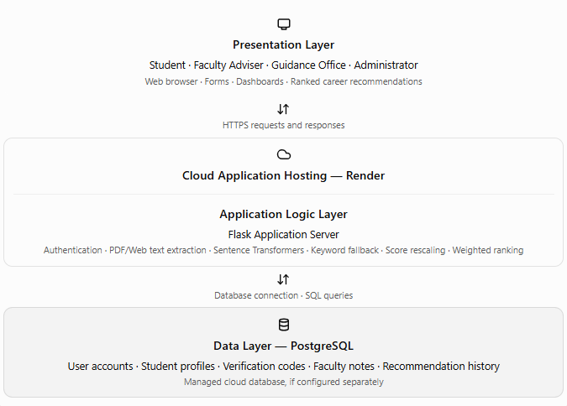

Presentation Layer
The Presentation Layer provides the user interfaces through which students, faculty advisers, Guidance Office personnel, and system administrators interact with CareerCompass. It presents the system's forms, pages, dashboards, and recommendation results through a web browser. Students use this layer to submit their General Weighted Average (GWA), career-interest ratings, and PDF portfolio or e-portfolio link. The system displays the resulting ranked career-path recommendations to students. Faculty advisers and Guidance Office personnel access the student information and dashboard summaries relevant to their authorized responsibilities, while system administrators use the available administrative interfaces to manage user accounts and system settings. The Presentation Layer sends user requests to the Application Logic Layer and displays the processed results returned by the application server.
Application Logic Layer
The Application Logic Layer is implemented using a Flask application server. It handles user authentication, input validation, portfolio text extraction, semantic similarity scoring using the Sentence-Transformers model all-MiniLM-L6-v2, and keyword matching as a fallback when the semantic model is unavailable. It also performs min-max rescaling of portfolio similarity scores and synthesizes the portfolio, career-interest, and GWA sub-scores using the system's weighted recommendation approach. The resulting scores are used to rank career-path recommendations and generate relevant dashboard summaries for authorized faculty and Guidance Office users. This layer processes requests received from the Presentation Layer and communicates with the Data Layer to retrieve or store the records required by the system.

Data Layer
The Data Layer uses PostgreSQL as the relational database management system for storing and retrieving application records, including user accounts, student profiles, verification codes, faculty notes, and recommendation history, as applicable to the implemented system. PostgreSQL replaces the previously used SQLite database to support the system's current database configuration and planned cloud deployment. The application server communicates with the database to process authorized data requests and persist the information required by the recommendation system. This layer provides the data storage and retrieval functions needed by the Application Logic Layer while keeping database operations separate from the user interface
Cloud Deployment
For cloud deployment, the Flask application is intended to be hosted through Render, while PostgreSQL can be provided through a managed PostgreSQL database service. In this deployment arrangement, users access CareerCompass through a web browser over HTTPS, requests are processed by the hosted Flask application, and database operations are performed through the configured PostgreSQL connection. Application configuration values, including database connection details and secret keys, are managed through environment variables rather than being embedded directly in the source code. This deployment approach separates the user interface, application processing, and database storage while making the system accessible online without requiring users to install the application locally.
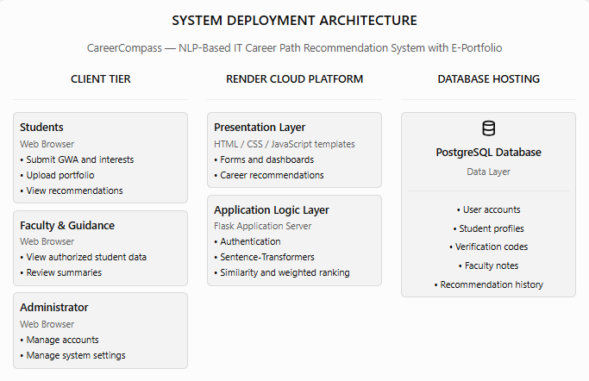

Level 0 Data Flow Diagram (Context Diagram)
The Level 0 Data Flow Diagram shows the two main external entities that interact with CareerCompass: the BSIT Student and the Guidance/Administrator. The BSIT Student submits profile details, career-interest responses, and e-portfolio content to the CareerCompass web application and receives personalized career recommendations in return. The Faculty/Administrator interacts with the system through the administrative and faculty functions available in the application, such as accessing the student directory, reviewing available reports, and managing accounts or system settings where these functions are implemented.

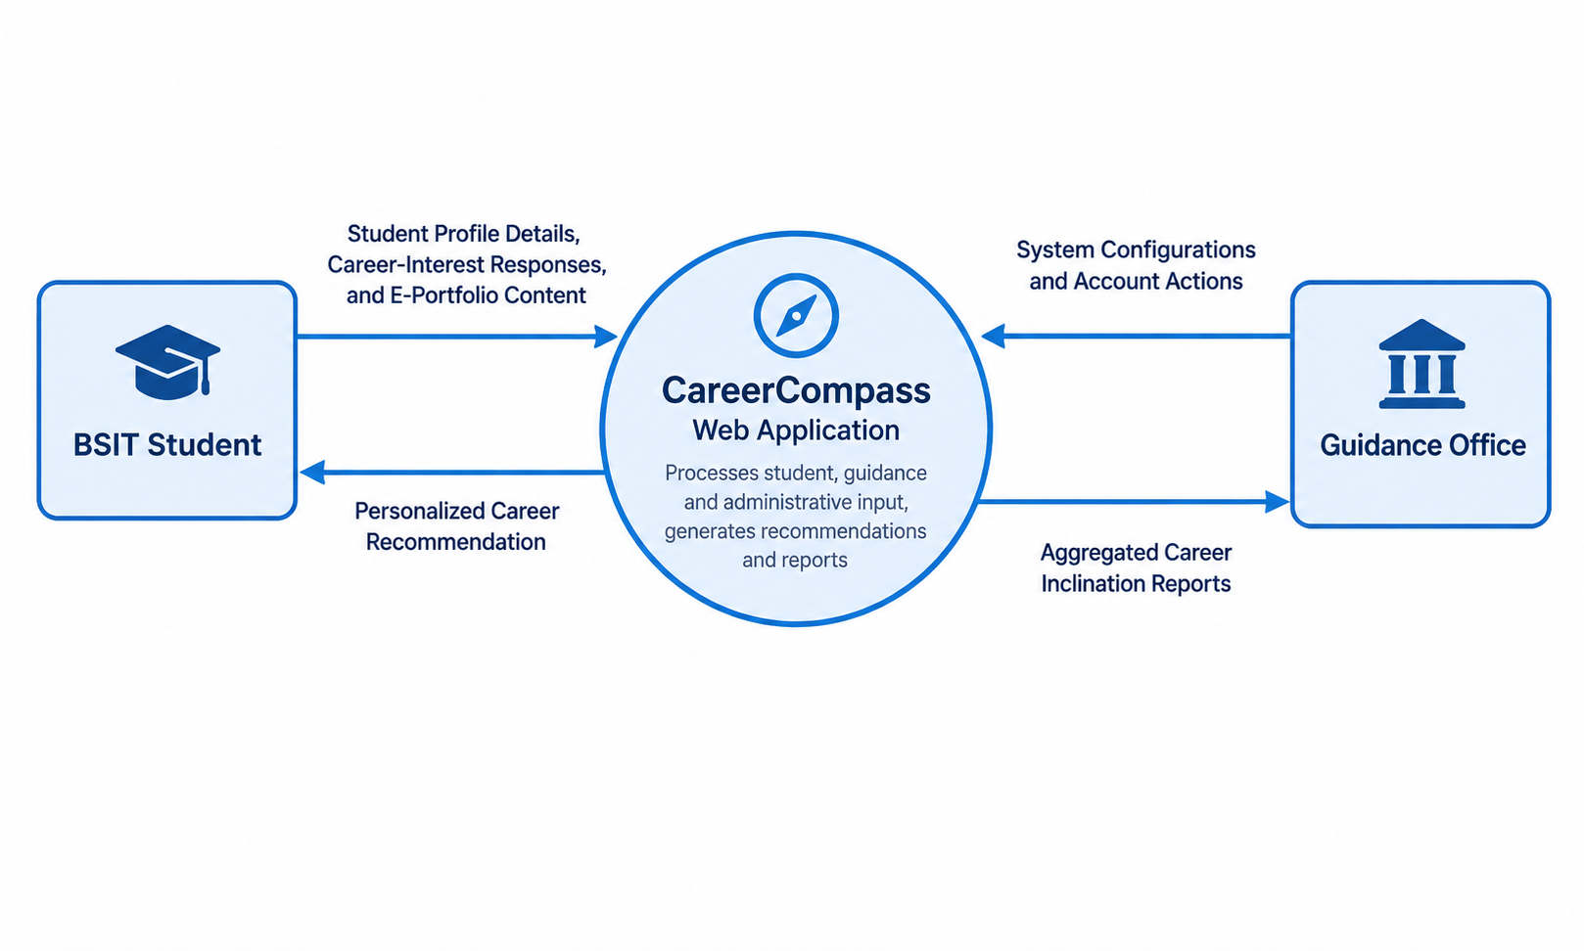

The CareerCompass web application serves as the core process that receives user inputs, processes student information and portfolio content, generates career recommendations, and provides the corresponding outputs based on each account's available functions. These data exchanges illustrate the system's main interactions at Level 0. Lower-level data flow diagrams may further decompose the recommendation process into portfolio text extraction, semantic embedding, similarity rescaling, and weighted score synthesis.

Algorithm Discussion
CareerCompass’s recommendation logic is NLP-based rather than a trained classifier: it combines a pretrained sentence-embedding model with a transparent, hand-weighted scoring formula. No component of the pipeline is fitted to a labeled dataset of PLP BSIT outcomes, which is why the study describes the system as NLP-based / semantic-matching-based, consistent with the discussion in the Recommendation Algorithms and Techniques section of Chapter 1, rather than as a machine-learning classifier trained on the institution’s own data.
The recommendation algorithm begins when a student submits the career assessment form, which includes the student’s GWA, a self-rated interest level for each of the five career tracks, and a PDF portfolio or a public e-portfolio link. The GWA and interest ratings are processed directly into numeric sub-scores, while the portfolio is handled separately: PDF text is extracted with PyMuPDF, and public website text is captured with requests and BeautifulSoup. Following Wang et al. (2020), the extracted portfolio text is converted into embeddings using the all-MiniLM-L6-v2 sentence-transformer model. For example, if a student portfolio contains repeated evidence of Python programming, web development projects, and data-analysis work, the system compares that text against the career-track descriptions and ranks Data Science and Analytics, Software Engineering, Web Development, Cybersecurity, and Network Engineering according to semantic similarity. Al-Dossari et al. (2020) and Wan and Ye (2022) support the use of career-description matching in this kind of recommendation flow.
The system also records supporting skill evidence by identifying relevant keywords and phrases in the submitted text. When the semantic model is unavailable, the keyword matching fallback keeps the portfolio-analysis feature active so the recommendation pipeline still works.
Because raw cosine similarity values tend to cluster in a narrow range and rarely reach 0 or 1 in practice, the five portfolio similarity scores are rescaled using min-max normalization to a 45%-95% range before they are used any further. This keeps the displayed portfolio score from looking like an absolute pass or fail while still preserving the relative ranking among the five career tracks. The rescaled portfolio score for each track is then combined with the student’s GWA sub-score and interest sub-score for that same track using a weighted synthesis of 65% portfolio, 20% interests, and 15% GWA. The portfolio component is weighted most heavily because it reflects demonstrated project work, while the interest and GWA components adjust the ranking toward tracks the student is both motivated to pursue and academically prepared for. These weights were set by the researchers based on the relative importance given to demonstrated work versus stated preference and academic standing, and are presented to evaluators as a transparent, adjustable design choice rather than a value learned from data.
The GWA sub-score used in this weighted synthesis is computed with the Academic Readiness Score formula implemented in the system:
Academic Readiness Score = ((5.00 − GWA) / 4.00) × 100
which maps the Philippine university GWA scale, where 1.00 is the highest possible grade and 5.00 is the lowest, onto a 0%-100% readiness score. Under this formula, a GWA of 1.00 converts to a 100% score, a GWA of 2.00 converts to 75%, a GWA of 3.00 converts to 50%, and a GWA of 5.00 converts to 0%.
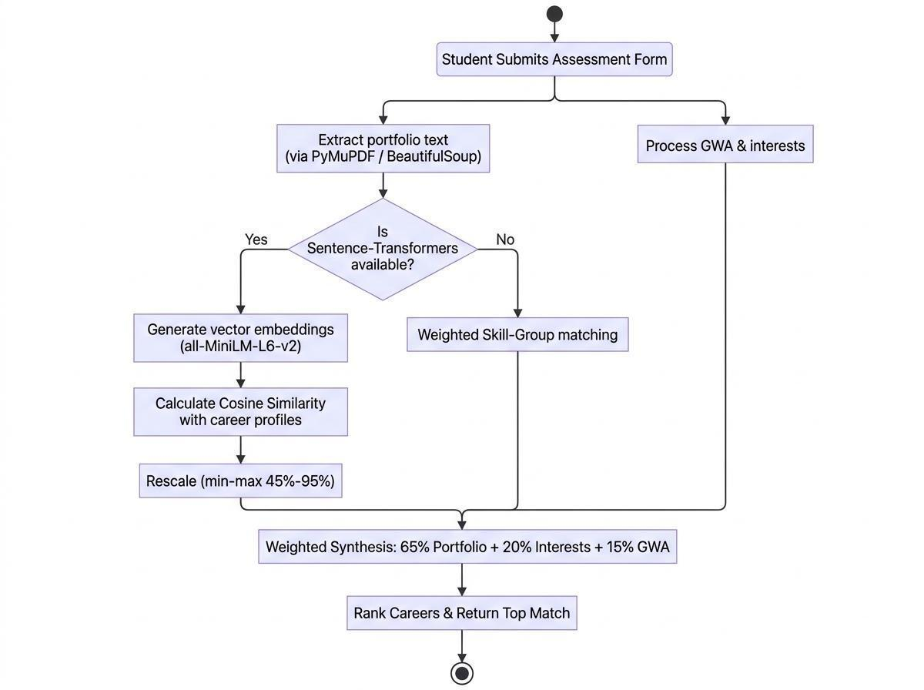
The system’s top-ranked track for a given portfolio will later be evaluated against expert judgment, rather than against a trained classifier, since no supervised model is fit to PLP’s own student data in this pipeline.
To illustrate how the ranking is produced, cosine similarity is computed as the cosine of the angle between two embedding vectors:
similarity(A, B) = (A · B) / (||A|| × ||B||)
where A is the embedding of the submitted portfolio text and B is the embedding of a career-track description, A · B is the dot product of the two vectors, and ||A|| and ||B|| are their magnitudes. A value close to 1 indicates that the portfolio and the career description are semantically close, while a value close to 0 indicates little semantic overlap.
Consider a simplified example using three-dimensional vectors for illustration; the actual system produces 384-dimensional vectors from the all-MiniLM-L6-v2 model. Suppose a student’s portfolio contains repeated mentions of “Python,” “data visualization,” and “regression model,” and its embedding is represented as A = [0.62, 0.55, 0.41]. The Data Science and Analytics career description embeds to B₁ = [0.60, 0.58, 0.39], while the Network Engineering description embeds to B₂ = [0.10, 0.22, 0.85].
1. Dot product of A and B₁ = (0.62×0.60) + (0.55×0.58) + (0.41×0.39) = 0.372 + 0.319 + 0.160 = 0.851
2. Magnitude of A = √(0.62² + 0.55² + 0.41²) = √(0.384 + 0.303 + 0.168) = √0.855 ≈ 0.925
3. Magnitude of B₁ = √(0.60² + 0.58² + 0.39²) = √(0.360 + 0.336 + 0.152) = √0.848 ≈ 0.921
4. Cosine similarity(A, B₁) = 0.851 / (0.925 × 0.921) ≈ 0.851 / 0.852 ≈ 0.999
Following the same steps for B₂: the dot product is (0.62×0.10) + (0.55×0.22) + (0.41×0.85) = 0.062 + 0.121 + 0.349 = 0.532; the magnitude of B₂ = √(0.010 + 0.048 + 0.723) = √0.781 ≈ 0.883; and cosine similarity(A, B₂) = 0.532 / (0.925 × 0.883) ≈ 0.532 / 0.817 ≈ 0.651.
Because the similarity score between the portfolio and Data Science and Analytics (≈ 0.999) is higher than the score between the portfolio and Network Engineering (≈ 0.651), Data Science and Analytics is ranked ahead of Network Engineering for this student. The same computation is repeated for all five career-track descriptions, and the tracks are then displayed to the student in descending order of similarity score, together with the keywords detected in the portfolio text as supporting evidence.
Continuing the example, suppose the cosine similarity scores for all five career tracks are min-max normalized and rescaled to the 45%-95% range, and Data Science and Analytics receives the highest rescaled portfolio score of 95%. If the same student rated their interest in Data Science and Analytics at 90% and has a GWA of 1.32, the Academic Readiness Score formula converts this to a GWA sub-score of ((5.00 − 1.32) / 4.00) × 100 = 92%. The final weighted score for that track is then computed as: (0.65 × 95) + (0.20 × 90) + (0.15 × 92) = 61.75 + 18.00 + 13.80 = 93.55%. The same computation is repeated for the remaining four tracks, and CareerCompass displays the tracks to the student in descending order of this final weighted score, together with the keywords detected in the portfolio text as supporting evidence.

Software Engineering Paradigm
The development of CareerCompass follows an Agile, iterative, and incremental paradigm. Requirements are refined from Chapter 1, the system is implemented in small modules, and each module is reviewed before the next increment is added. According to Pressman and Maxim (2020) and Schwaber and Sutherland (2020), this approach supports rapid adjustment of the dashboard, extraction logic, and recommendation flow based on testing feedback.
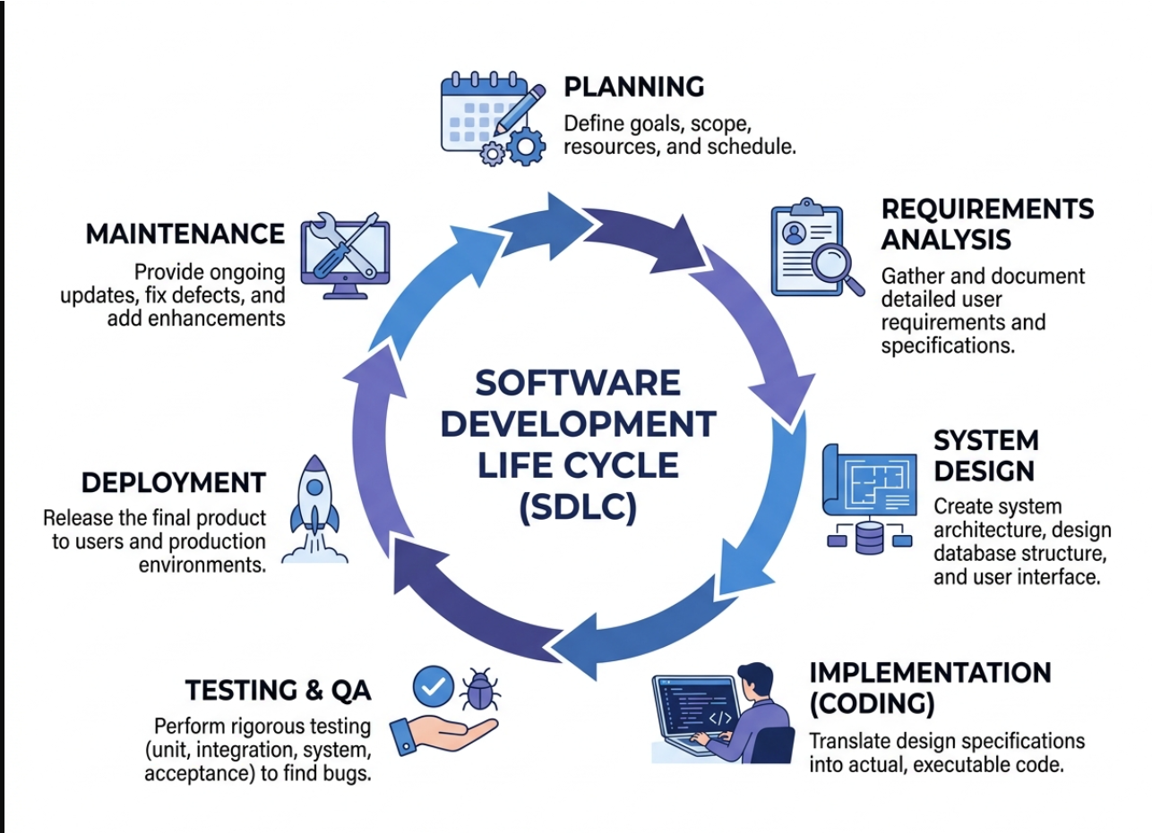
The project followed the seven phases of the Software Development Life Cycle shown in Figure 6: Planning, Requirements Analysis, System Design, Implementation, Testing and QA, Deployment, and Maintenance. Planning defined the project goals, scope, and schedule, while Requirements Analysis, informed by Chapter 1, gathered the detailed user requirements of BSIT students, faculty advisers, and the Guidance Office. System Design covered the three-tier architecture, database schema, and interface layout described earlier in this chapter, and Implementation translated those design specifications into the Flask application, the extraction and embedding pipeline, and the student, faculty, and administrator interfaces. Testing and QA covered unit, integration, system, and acceptance testing of the recommendation pipeline and dashboards, Deployment released the working prototype for evaluation, and Maintenance covers the ongoing updates, defect fixes, and enhancements made in response to adviser and user feedback. Rather than completing these seven phases once in a single linear pass, the team executed them iteratively within each one-to-two-week Agile sprint, so that a smaller version of the full SDLC, from planning a sprint’s tasks to testing and reviewing the resulting increment, is repeated every cycle described below.
Development proceeds in short sprints of one to two weeks. Each sprint begins with the team reviewing the outstanding tasks in the project backlog, assigning tasks such as the extraction module, the embedding and ranking module, or a specific dashboard view, and ends with a working increment that the group and the adviser can review. Feedback gathered from each review, including corrections to the architectural framework, the algorithm, or the interface, is incorporated into the backlog for the next sprint. This iterative cycle allows the researchers to test the semantic-matching pipeline early with sample portfolios, rather than waiting until the entire system is complete, which reduces the risk of discovering major design problems late in development.

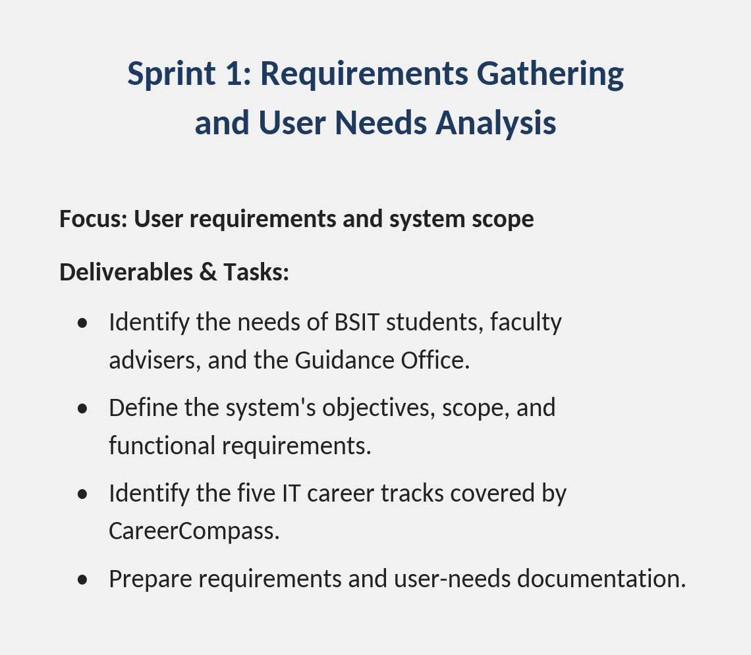
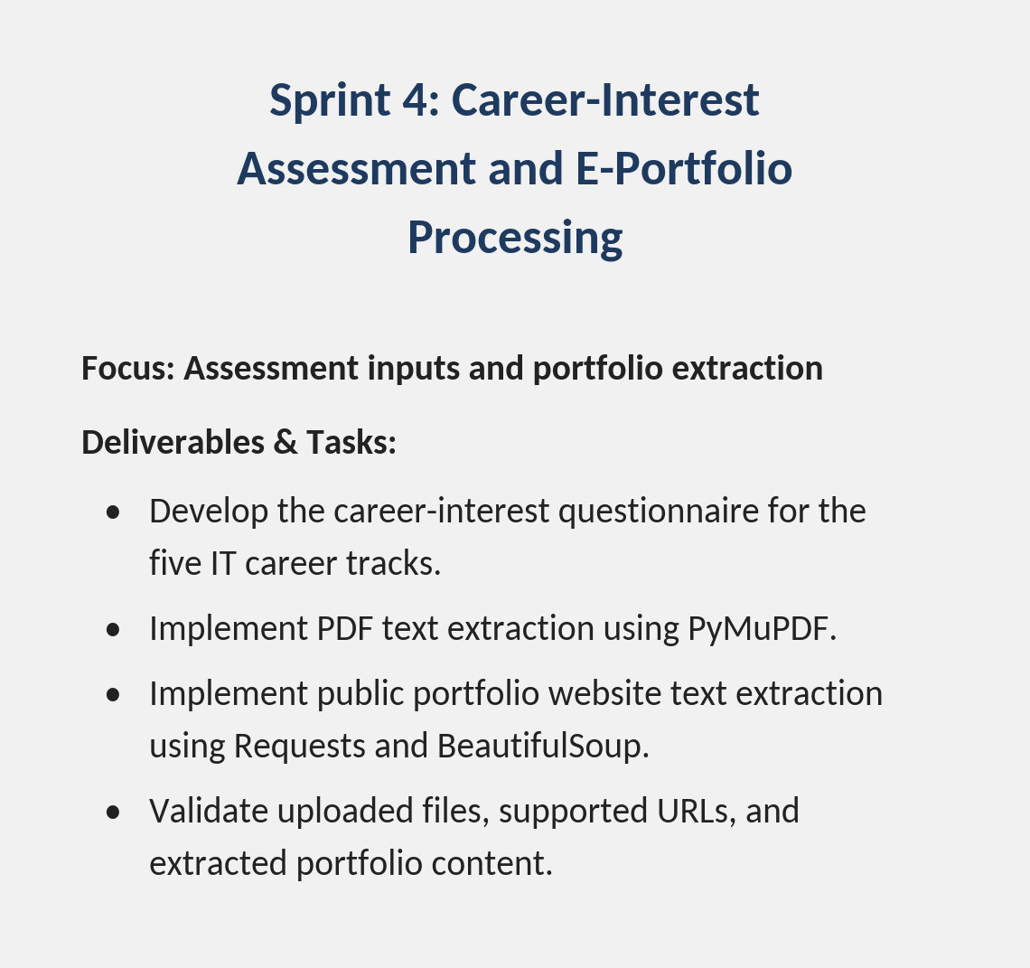
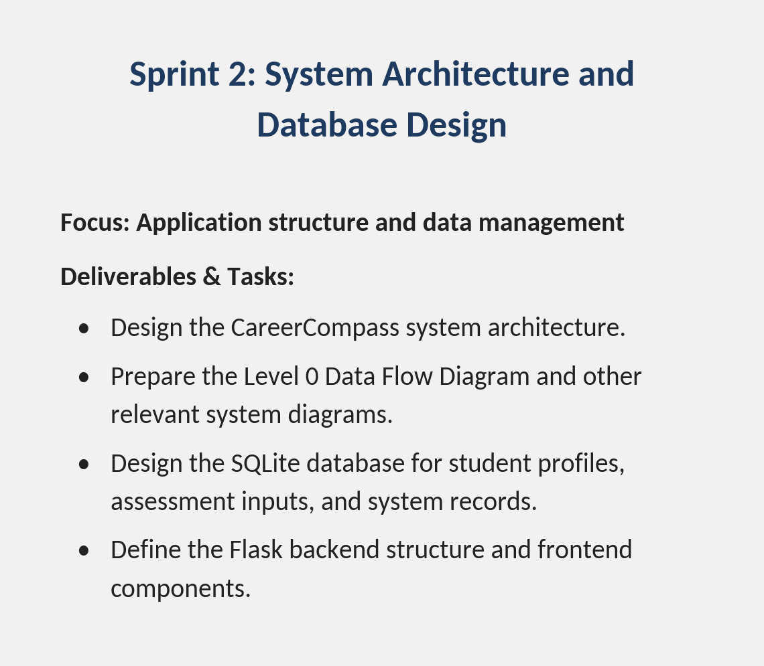
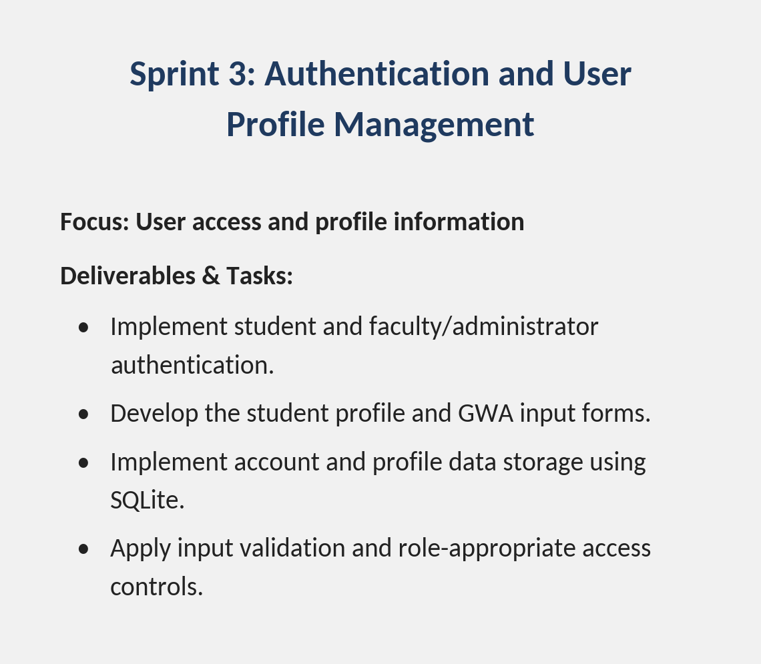
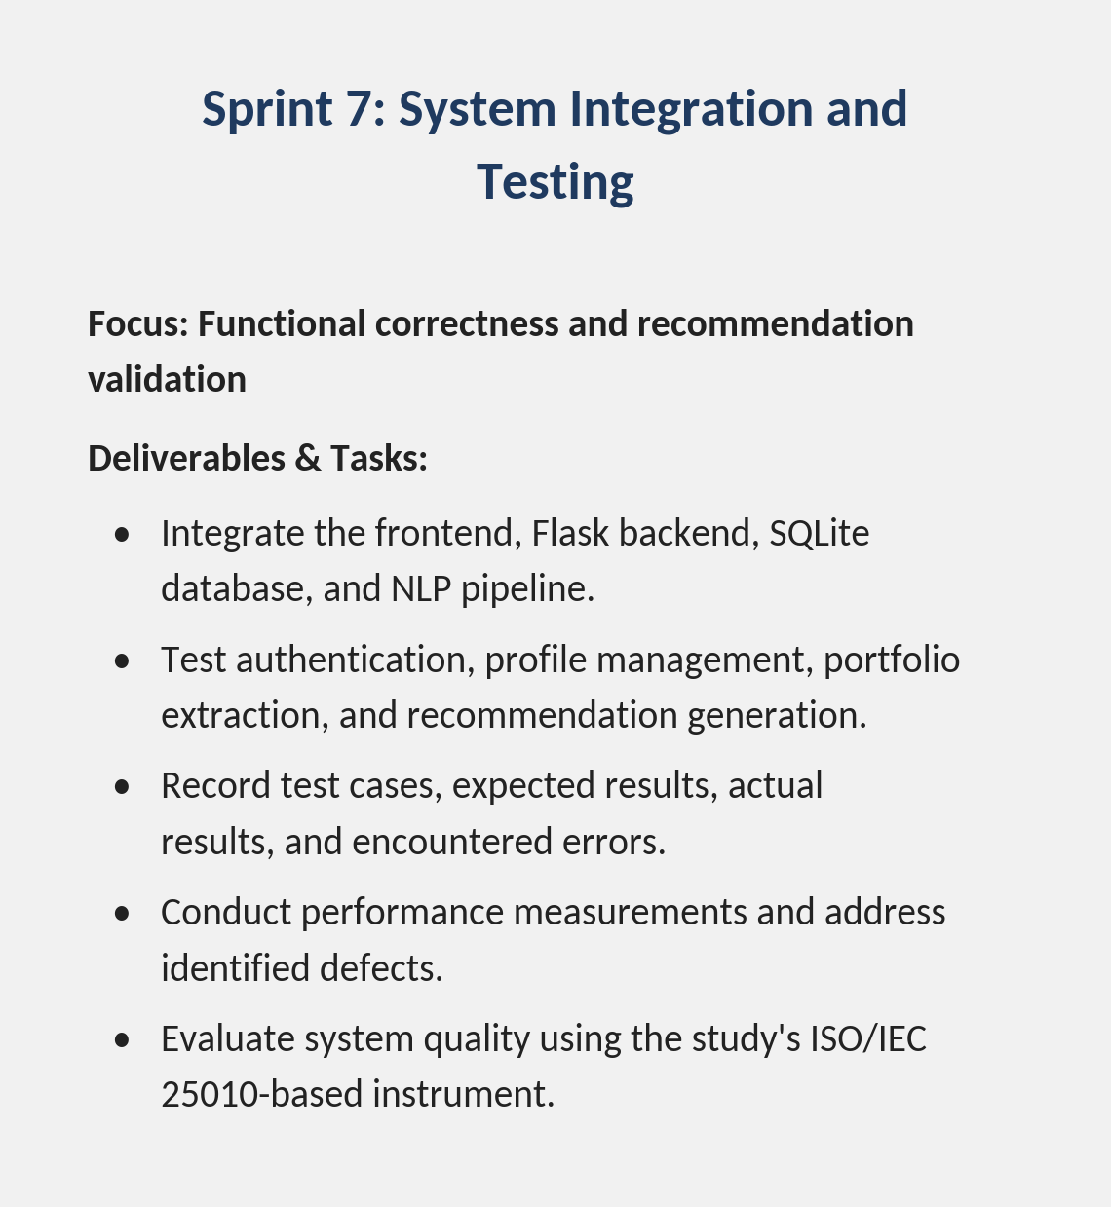
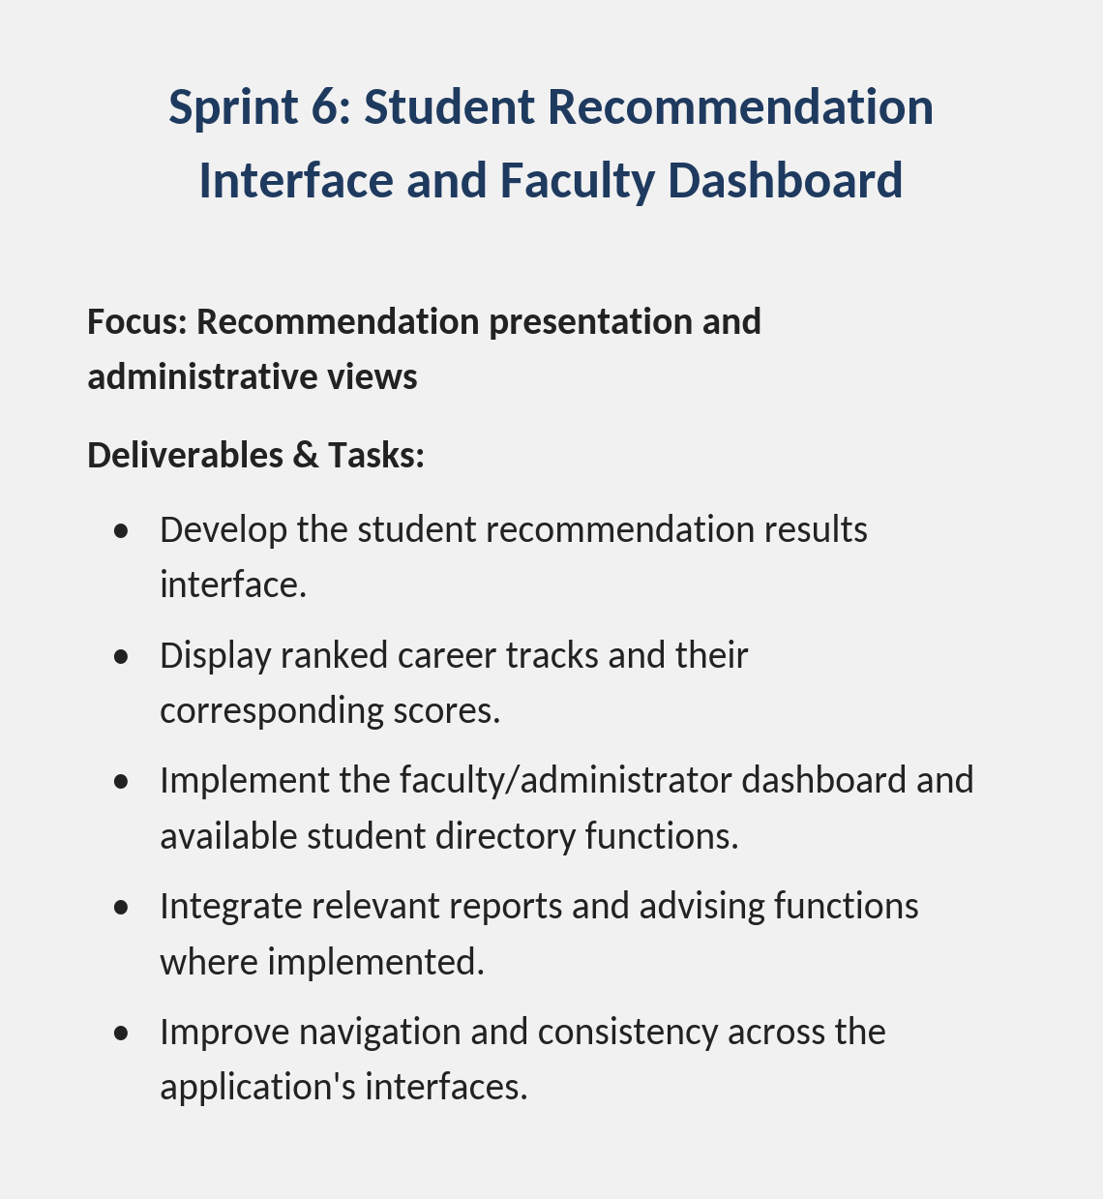
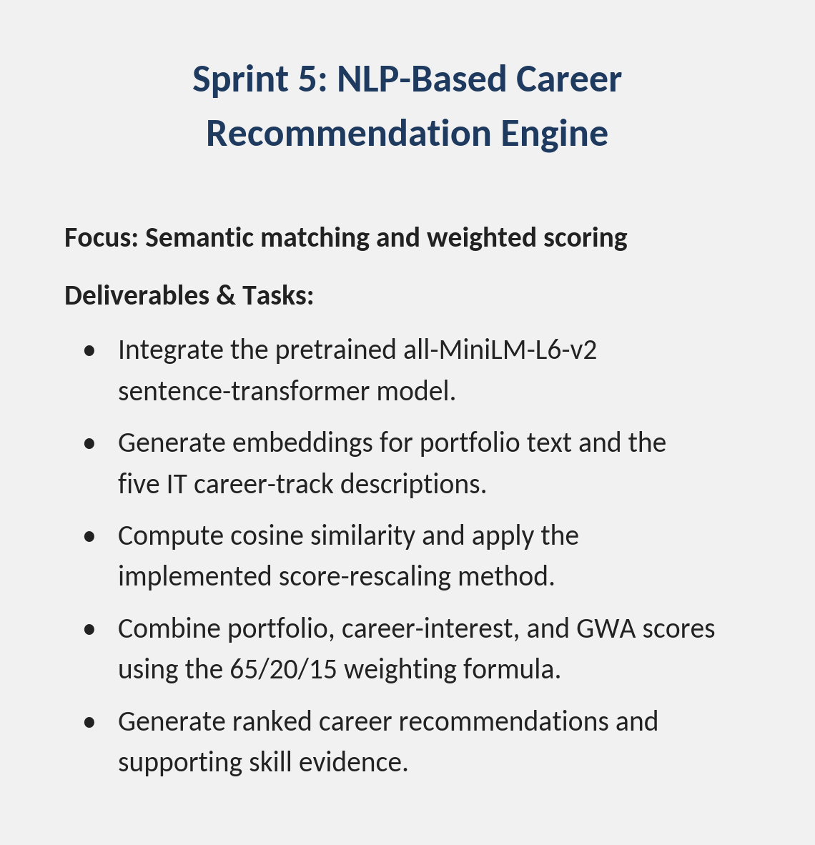
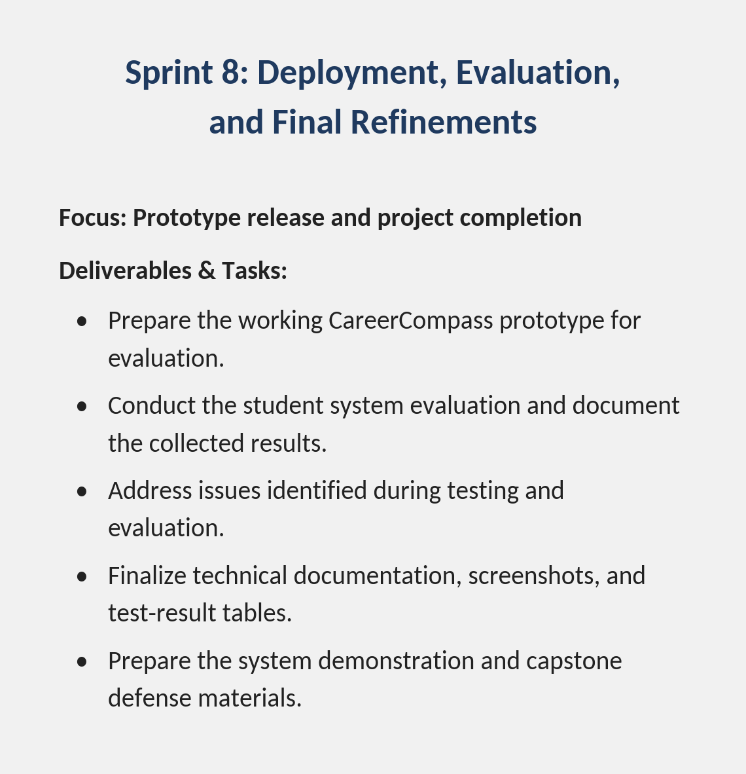

Population and Sampling
The target population consists of BSIT students of Pamantasan ng Lungsod ng Pasig, along with faculty advisers and Guidance Office staff who can validate the system outputs. Purposive sampling is appropriate because the respondents must match the intended users of the system and have enough context to evaluate portfolio-based career recommendations. For a practical evaluation set, the study may include at least 60 BSIT students, a small group of faculty advisers, and a Guidance Office representative so the system can be checked from both student and institutional perspectives. Wan and Ye (2022) and Cui (2024) support this kind of student-centered evaluation approach.
BSIT students of PLP were selected as the primary population because they are the intended end users of the recommendation feature, while faculty advisers and Guidance Office staff were included because they are expected to use the dashboard views to support counseling and monitoring. Purposive sampling was chosen over random sampling because the evaluation requires participants who are already familiar with the career-guidance process at PLP and who can meaningfully judge whether the recommendations and dashboards reflect real student competencies; a randomly selected participant outside these roles would not be able to provide this kind of informed evaluation. The target of at least 60 BSIT student-respondents follows a practical minimum for descriptive evaluation studies at the college level, and the inclusion of faculty advisers and a Guidance Office representative ensures that the system is judged from the perspective of both its primary users and the institutional stakeholders who will rely on its aggregated data.

Data Collection Methods
The researchers collected data through a structured questionnaire administered using Google Forms to identify the IT career guidance needs and desired system features of BSIT students. The collected responses served as a basis for determining the requirements of CareerCompass during system development. The data collection process focused on understanding the difficulties students experienced when choosing an IT career path, the factors they considered important in career selection, and the features they expected from a career recommendation system.
Instrumentation
The primary research instrument used in this study was a structured questionnaire developed through Google Forms entitled CareerCompass: IT Career Guidance Needs and System Requirements Survey. The instrument was designed to gather information about BSIT students' experiences with IT career guidance, difficulties in selecting a career path, information needed when exploring IT careers, and preferred features of the proposed CareerCompass system.
The questionnaire consisted of multiple-choice questions, checkbox questions, rating-scale items, and an open-ended question. These question formats allowed the researchers to collect both quantitative responses and descriptive feedback. The quantitative items gathered information about respondents' career interests, guidance needs, preferred system features, and willingness to use CareerCompass, while the open-ended question allowed respondents to suggest additional features.
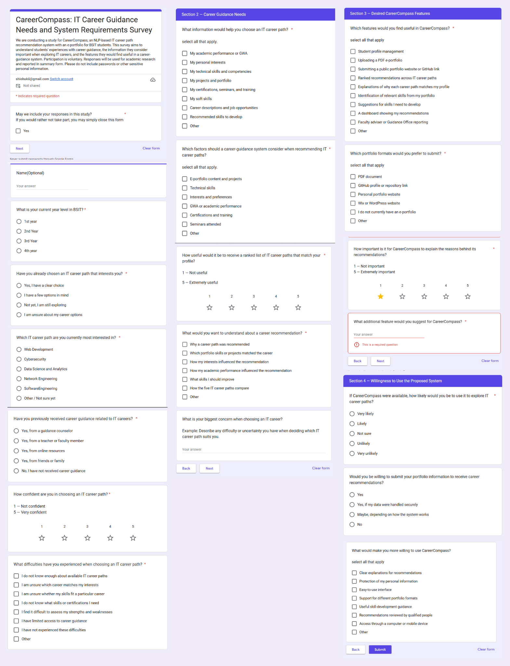
The questionnaire served as the primary instrument for identifying user needs and informing the proposed system requirements. Its responses were analyzed separately from the system evaluation results discussed in Chapter 3.

Structured Questionnaire

The researchers designed and administered a structured questionnaire using Google Forms based on the objectives of the study, the identified research problem, and relevant findings from the Review of Related Literature. The questionnaire was organized into four sections:
- Respondent Profile. This section gathered information about the respondents' current year level in the BSIT program, existing IT career interests, previous exposure to career guidance, confidence in selecting an IT career path, and difficulties encountered during career selection.
- Career Guidance Needs. This section identified the information and factors respondents considered important when choosing an IT career path, including academic performance, personal interests, technical skills, portfolio projects, certifications, seminars, and training. It also explored the usefulness of receiving ranked career recommendations and explanations of the results.
- Desired CareerCompass Features. This section asked respondents which features they considered useful, including student profile management, PDF portfolio uploads, public portfolio links, ranked career recommendations, explanations of recommendation results, identification of relevant skills, skill-development suggestions, and faculty or Guidance Office reporting.
- Willingness to Use the Proposed System. This section examined respondents' willingness to use CareerCompass, their willingness to submit portfolio information, and the conditions that could encourage their use of the system, such as data protection, understandable recommendations, ease of use, and relevant skill-development guidance.
The questionnaire was distributed through Google Forms using the communication channels available to the researchers. Participation was voluntary, and respondents were informed of the study's purpose. Submitted responses were automatically recorded and organized for analysis. Closed-ended responses were summarized using frequencies and percentages, rating-scale items were analyzed using appropriate descriptive statistics, and open-ended responses were reviewed for recurring themes related to career guidance needs and desired system features.
The findings from the structured questionnaire were used to describe the respondents' reported needs and preferences and to inform the system requirements of CareerCompass. The questionnaire captured respondents' stated needs and expectations; it was not used by itself to establish the accuracy of the system's career recommendations.

Step 1: Questionnaire Design
The researchers designed a structured questionnaire entitled CareerCompass: IT Career Guidance Needs and System Requirements Survey. The questionnaire consisted of four sections: Respondent Profile, Career Guidance Needs, Desired CareerCompass Features, and Willingness to Use the Proposed System.
The Respondent Profile section gathered information about the participants' year level in the BSIT program, current IT career interests, previous exposure to career guidance, confidence in choosing an IT career path, and difficulties experienced during career selection. The Career Guidance Needs section identified the information and factors respondents considered important when exploring IT careers, including academic performance, personal interests, technical skills, portfolio evidence, certifications, and training. The Desired CareerCompass Features section gathered preferences regarding system functions such as portfolio submission, ranked career recommendations, explanations of recommendation results, and skill-development suggestions. The final section examined respondents' willingness to use CareerCompass and the conditions that could encourage them to use the proposed system.

Step 2: Questionnaire Distribution
The questionnaire was distributed to BSIT students through Google Forms and the communication channels actually used by the researchers. Respondents were invited to participate voluntarily and provide information about their career guidance needs, challenges in selecting an IT career path, and expectations for a career recommendation system.

Step 3: Participation and Informed Consent
Participation was voluntary. Respondents were informed of the purpose of the study and the intended use of their responses. They could decline participation and were instructed not to provide passwords or other sensitive personal information. Names were optional, and respondents were asked to provide only information necessary for the research.

Step 4: Response Collection and Analysis
Responses submitted through Google Forms were automatically recorded. The researchers reviewed the collected responses for completeness and organized them for analysis. Closed-ended responses were summarized using frequencies and percentages, while rating-scale questions were analyzed using appropriate descriptive statistics. Open-ended responses were reviewed and grouped into recurring themes related to career guidance difficulties, desired system features, and suggested improvements.
The findings were used to describe the career guidance needs and preferred system features reported by the respondents. These findings were considered alongside the research objectives and related literature when documenting the requirements of CareerCompass.

Step 5: Requirements Identification
The researchers analyzed the collected responses to identify common career guidance needs, challenges in selecting IT career paths, and desired system features. The findings were used as a reference when defining the functional requirements and features of CareerCompass. These included collecting student profile information, considering career interests and GWA, accepting e-portfolio content, and generating ranked IT career recommendations. The responses were considered alongside the objectives and scope of the study when determining which features to include in the system.

Data Analysis Procedures
This section presents the results of the questionnaire administered to sixty (60) BSIT students. The analysis covers the respondents' year levels, IT career preferences, current career-choice status, previous career guidance experiences, confidence in choosing an IT career path, and difficulties encountered during career selection. It also includes their responses regarding the proposed CareerCompass system and its features, as covered by the questionnaire. The findings served as the basis for identifying students' career guidance needs and determining the system features intended to support IT career path recommendations through natural language processing and an e-portfolio
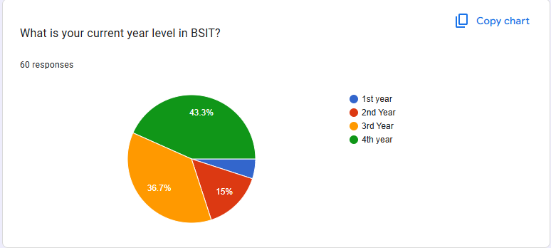

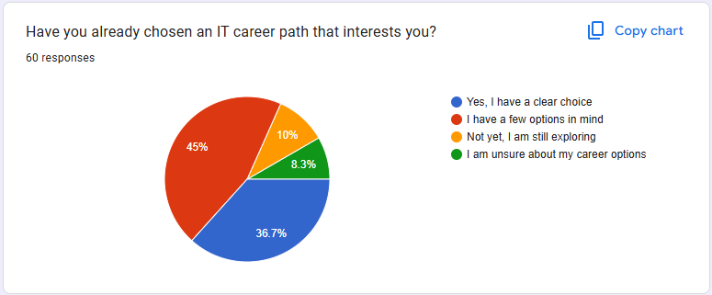
Figure 2.1 presents the year levels of the 60 respondents. Fourth-year students comprised the largest group, with 26 respondents (43.3%), followed by third-year students with 22 respondents (36.7%). Second-year students accounted for 9 respondents (15%), while first-year students represented 3 respondents (5%). The results show that most participants were third- and fourth-year BSIT students.

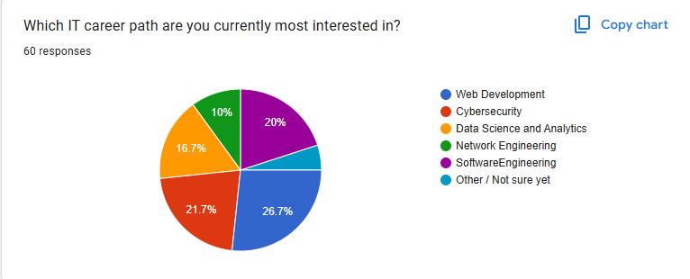
Figure 2.2 presents the respondents' current status in choosing an IT career path. The largest group consisted of students who had a few career options in mind, representing 27 respondents (45%). Meanwhile, 22 respondents (36.7%) had already made a clear career choice. Six respondents (10%) were still exploring their options, while 5 respondents (8.3%) were unsure about the available options. These results indicate that some students had identified possible career paths but had not yet settled on a specific choice.

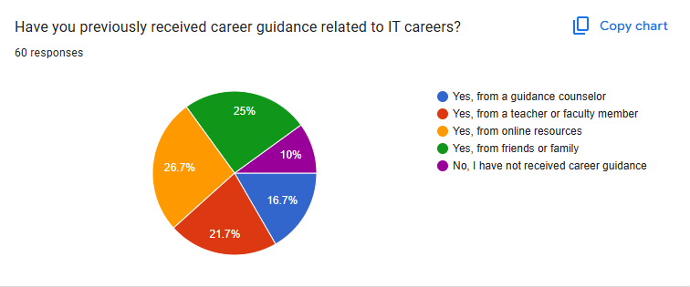
Figure 2.3 shows the IT career paths that interested the respondents most. Web Development ranked first, selected by 16 respondents (26.7%). Cybersecurity followed with 13 respondents (21.7%), while Software Engineering was selected by 12 respondents (20%). Data Science and Analytics accounted for 10 respondents (16.7%), and Network Engineering was selected by 6 respondents (10%). The remaining 3 respondents (5%) selected another option or were unsure. These findings show that Web Development was the most frequently selected career path among the respondents.

Figure 2.4 presents the sources of career guidance previously consulted by the respondents. Online resources were the most frequently reported source, selected by 16 respondents (26.7%). Friends or family accounted for 15 respondents (25%), while teachers or faculty members were reported by 13 respondents (21.7%). Guidance counselors were selected by 10 respondents (16.7%), and 6 respondents (10%) indicated that they had not received previous career guidance. The results show that students obtained career-related information from a combination of online and personal sources.
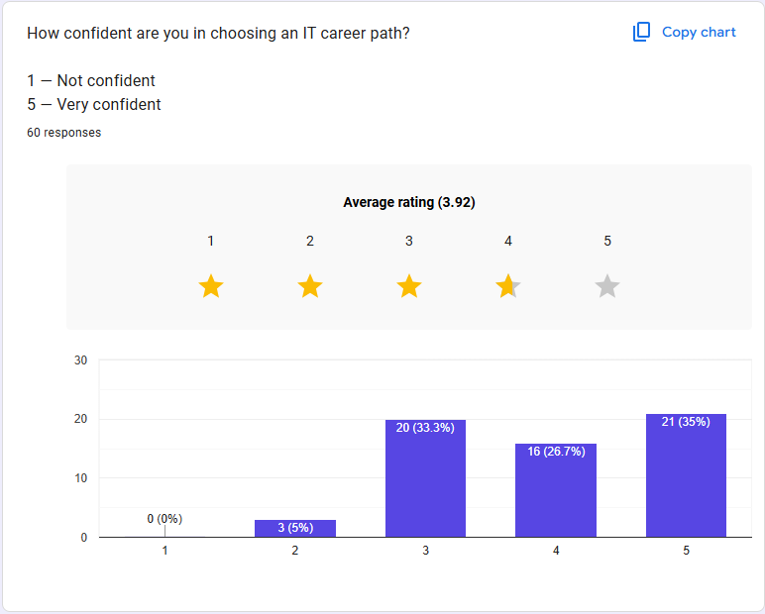

Figure 2.5 presents the respondents' self-reported confidence in choosing an IT career path. The overall mean rating was 3.92 out of 5. This result summarizes the respondents' reported confidence based on the rating scale used in the questionnaire. The individual response distribution should also be presented to show how respondents rated their confidence.
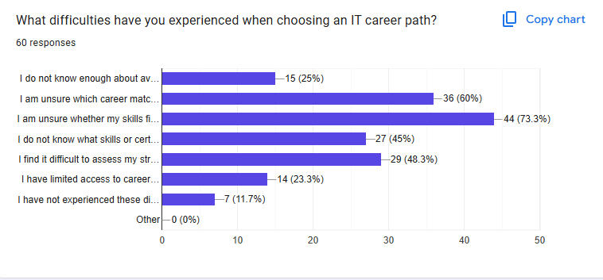

Figure 2.6 presents the difficulties respondents encountered when selecting an IT career path. The most frequently reported difficulty was uncertainty about whether their skills fit a particular career, selected by 44 respondents (73.3%). This was followed by uncertainty about which career matched their skills, reported by 36 respondents (60%). Difficulty assessing personal strengths was selected by 29 respondents (48.3%), while 27 respondents (45%) were uncertain about the skills or certifications required for their chosen careers.
Additionally, 15 respondents (25%) reported limited knowledge of available IT careers, and 14 respondents (23.3%) indicated limited access to career guidance. Seven respondents (11.7%) reported experiencing no difficulties. Since respondents could select multiple answers, the percentages do not necessarily total 100%. Overall, the results highlight concerns about matching personal skills to career requirements and identifying suitable IT career paths.
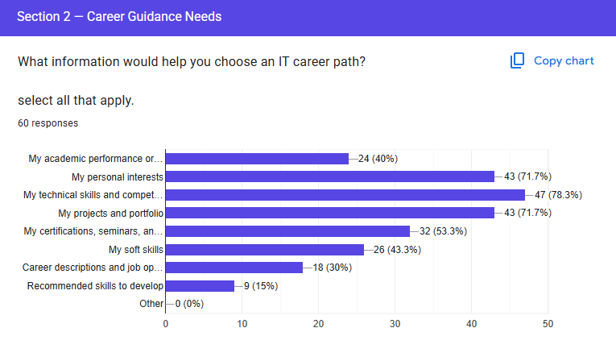

Figure 2.7 shows that technical skills and competencies were selected by 47 respondents (78.3%) as information that would help them choose an IT career path. Personal interests and projects or portfolio information were each selected by 43 respondents (71.7%). Certifications and related training were also frequently selected, along with soft skills and academic performance. These findings indicate that students want career guidance to consider more than their preferred job title. CareerCompass should therefore consider relevant information about students’ competencies, interests, academic background, and portfolio when generating career recommendations.

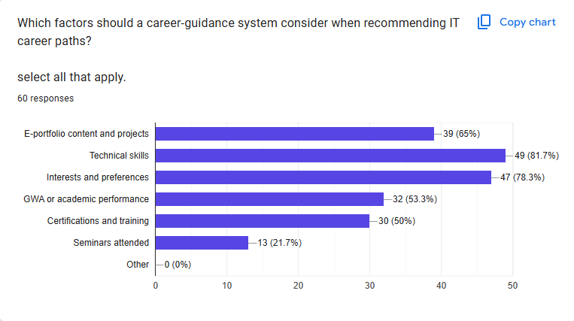

Figure 2.8 shows that technical skills were selected by 49 respondents (81.7%), making them the most frequently chosen factor for career recommendations. Interests and preferences followed, with 47 respondents (78.3%), while e-portfolio content and projects were selected by 39 (65%). Academic performance was selected by 32 respondents (53.3%), and certifications and training were selected by 30 (50%). Seminars attended were selected by 13 respondents (21.7%). These results suggest that respondents value recommendations based on their skills and personal interests, supported by evidence of their work and other relevant qualifications. These factors can guide the selection of information used by CareerCompass when matching students with suitable IT career paths.
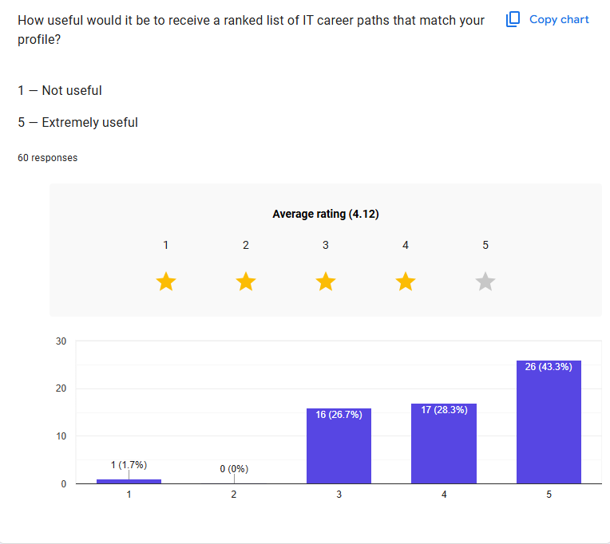

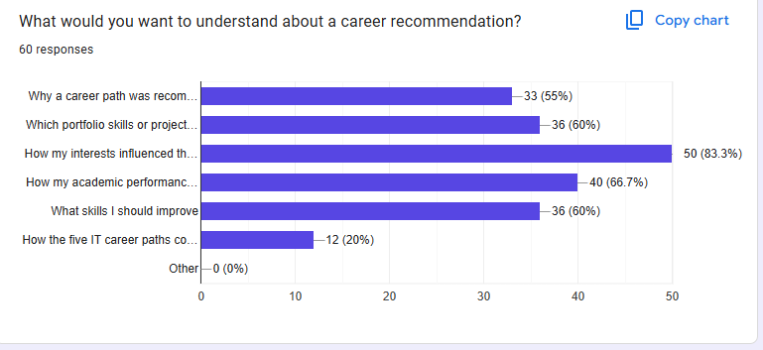
Figure 2.9 shows that the respondents gave the usefulness of receiving a ranked list of IT career paths an average rating of 4.12 out of 5. Twenty-six respondents (43.3%) rated the feature as 5, while 17 (28.3%) rated it as 4. Sixteen respondents (26.7%) selected a rating of 3, and one respondent (1.7%) selected a rating of 1. No respondent selected a rating of 2. The results indicate that respondents generally considered ranked career recommendations useful. This supports the inclusion of a feature that presents career paths in an ordered list to help students review options that may match their profiles.

Figure 2.10 shows that the most frequently selected information was how personal interests influenced the recommendation, chosen by 50 respondents (83.3%). Forty respondents (66.7%) wanted to understand how academic performance influenced the recommendation. The skills or projects from their portfolios that matched a career and the skills they should improve were each selected by 36 respondents (60%). Meanwhile, 33 respondents (55%) wanted to know why a particular career path was recommended, and 12 (20%) wanted to compare the five IT career paths. These results emphasize the importance of making recommendations understandable to users. CareerCompass should explain the factors behind its suggestions and identify relevant skills or projects that support each recommendation.

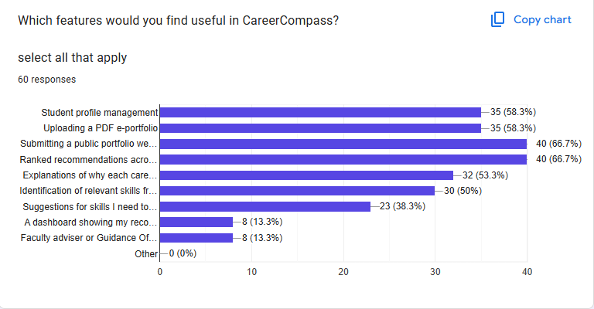

Figure 2.11 shows that the most frequently selected features were ranked recommendations across IT career paths and the ability to submit a public portfolio website or GitHub link, each selected by 40 respondents (66.7%). Student profile management and uploading a PDF e-portfolio were each selected by 35 respondents (58.3%). Explanations of why each career path matches a student’s profile were selected by 32 respondents (53.3%), while identification of relevant skills from a portfolio was selected by 30 (50%). Suggestions for skills to develop were selected by 23 respondents (38.3%). Faculty adviser or Guidance Office reporting and a recommendation dashboard were each selected by eight respondents (13.3%). These findings indicate that respondents prioritize personalized recommendations, portfolio submission, profile management, and explanations of career matches. These preferences provide guidance for determining the main features of CareerCompass.
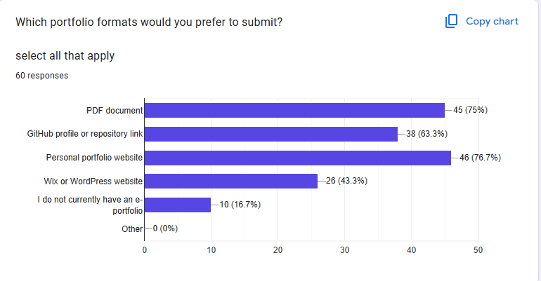

Figure 2.12 shows that a personal portfolio website was the most frequently selected format, with 46 respondents (76.7%). PDF documents were selected by 45 respondents (75%), while GitHub profiles or repository links were selected by 38 (63.3%). Twenty-six respondents (43.3%) preferred Wix or WordPress websites. Meanwhile, 10 respondents (16.7%) indicated that they did not currently have an e-portfolio. Since respondents could select more than one format, the percentages do not add up to 100%. The results show that students have different ways of presenting their work and skills. CareerCompass should consider supporting multiple portfolio formats to accommodate students with existing portfolios as well as those who have not yet created one.

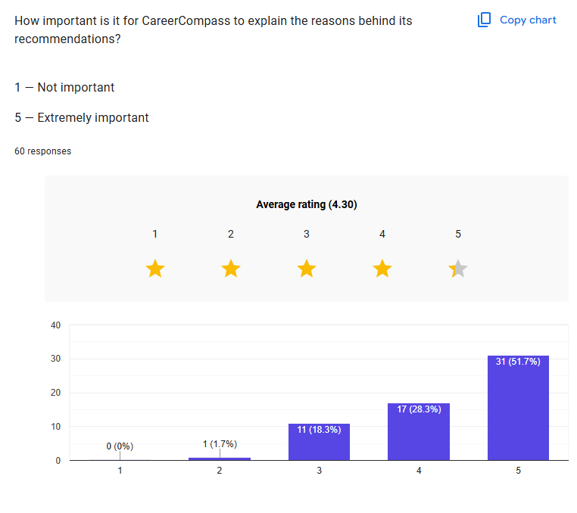

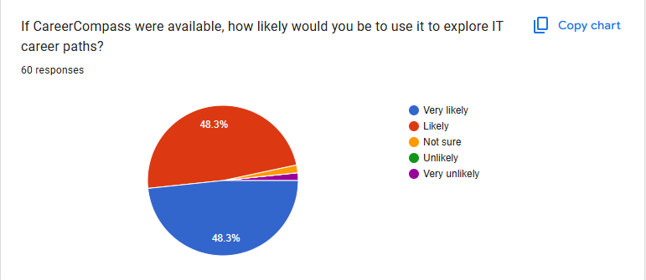
Figure 2.13 shows that the respondents gave an average rating of 4.30 out of 5 for the importance of explaining the reasons behind career recommendations. Thirty-one respondents (51.7%) gave a rating of 5, while 17 (28.3%) gave a rating of 4. Eleven respondents (18.3%) selected a rating of 3, and one respondent (1.7%) selected a rating of 2. No respondent selected a rating of 1. These results indicate that respondents generally consider explanations an important part of career guidance. CareerCompass should therefore provide understandable reasons for its recommendations, including the relevant skills, interests, and portfolio information associated with each suggested career path.

Figure 2.14 shows that the results show that 29 respondents (48.3%) were very likely to use CareerCompass, while another 29 (48.3%) were likely to use it to explore IT career paths. One respondent (1.7%) was very unlikely to use the system, and one (1.7%) was unsure. Overall, 58 out of 60 respondents (96.7%) expressed a positive likelihood of using CareerCompass. This indicates strong stated interest in the proposed system among the surveyed students. However, these responses reflect their reported intentions and do not, by themselves, establish actual system usage.

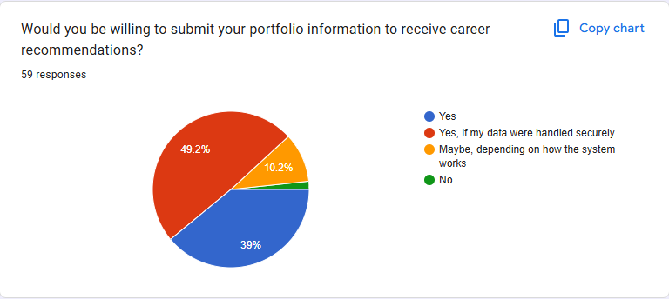

Figure 2.15 shows that fifty-nine respondents answered the question about submitting portfolio information for career recommendations. Of these, 29 respondents (49.2%) were willing to submit their information if their data were handled securely, while 23 (39.0%) answered yes without stating an additional condition. Six respondents (10.2%) answered that their decision would depend on how the system works, and one respondent (1.7%) was unwilling to submit portfolio information. The findings indicate that most respondents were open to providing portfolio information, but data security and privacy remain important considerations. CareerCompass should clearly communicate how portfolio information is used and protected.

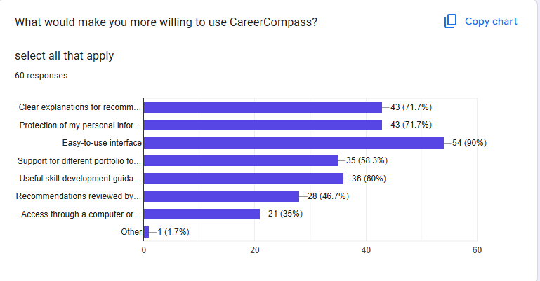

Figure 2.16 shows that an easy-to-use interface was the most frequently selected factor, chosen by 54 respondents (90%). Clear explanations for recommendations and protection of personal information were each selected by 43 respondents (71.7%). Useful skill-development guidance was selected by 36 respondents (60%), while support for different portfolio formats was selected by 35 (58.3%). Recommendations reviewed by qualified people were selected by 28 respondents (46.7%), and access through a computer or mobile device was selected by 21 (35%). These results suggest that usability, transparency, privacy, and practical guidance are important to the intended users. These considerations should be reflected in the design and presentation of CareerCompass.
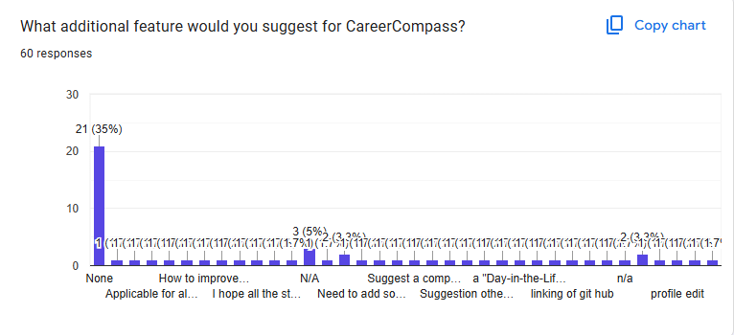

Figure 2.17 shows that the open-ended responses included suggestions related to improving skills, providing career guidance, expanding career options, and making the system more accessible. Some respondents expressed interest in recommendations for improving their strengths and weaknesses, learning roadmaps, notifications about skills, chatbot assistance, and better access through mobile devices. Other responses raised concerns about gaining experience and finding employment after graduation. These suggestions indicate that students may benefit from guidance that extends beyond receiving a list of recommended careers. Where feasible, such suggestions may inform future enhancements to CareerCompass.

Summary of Data Analysis
The questionnaire results reveal that respondents have varied IT career interests and different levels of certainty when choosing a career path. The most frequently reported difficulties involved determining whether their skills fit a career and identifying a career that matches their interests. Respondents also emphasized technical skills, personal interests, portfolio content, and academic information as relevant factors for career recommendations.
The results further show that respondents value ranked career recommendations, explanations of why careers match their profiles, and support for different e-portfolio formats. Most respondents also expressed a likelihood of using CareerCompass, while responses about submitting portfolio information highlighted the importance of data security and privacy. Overall, the findings provide a basis for designing CareerCompass around personalized career guidance, understandable recommendations, portfolio-based information, and practical support for students exploring IT career paths.

Ethical Considerations
The researchers ensured that the study adhered to the ethical principles of honesty, fairness, and respect for all participants. The researchers also followed the applicable rules and regulations of Pamantasan ng Lungsod ng Pasig (PLP) to protect the rights, privacy, and dignity of the respondents involved in the study. These principles guided the researchers throughout the collection, analysis, and interpretation of the data gathered for the proposed CareerCompass: An NLP-Based IT Career Path Recommendation System with E-Portfolio for BSIT Students.
Before answering the questionnaire through Google Forms, the respondents were informed of the purpose of the study and how their responses would contribute to understanding the career guidance needs and preferred features of the proposed system. Participation in the survey was voluntary, and respondents were informed that they could choose whether to participate without any penalty. By completing and submitting the questionnaire, respondents indicated their consent to participate in the study.
The researchers also ensured that the respondents’ personal information and individual answers were handled confidentially. Information that could identify the respondents was not disclosed in the presentation of the findings. The data gathered through Google Forms were used solely for the purposes of the study, particularly in analyzing the respondents’ career preferences, difficulties in choosing an IT career path, preferred e-portfolio formats, and expectations for CareerCompass. The results were summarized and presented using frequencies, percentages, and other appropriate descriptive statistics to represent the responses accurately and objectively.
This chapter presents the research methodology adopted for the study, including the research design, data-gathering procedure, and methods used to analyze the responses collected through Google Forms. The succeeding chapter presents the results derived from the questionnaire, together with the analysis and interpretation of the findings in relation to the research questions and objectives of the study. These findings serve as the basis for identifying the career guidance needs and preferred features to be considered in the proposed CareerCompass system.

Summary
This chapter presented the methodology used in the development of CareerCompass, an NLP-based IT career path recommendation system with e-portfolio for BSIT students of Pamantasan ng Lungsod ng Pasig. The study employed a descriptive-developmental research design to identify students’ career guidance needs and develop a system that addresses these needs. It also discussed the three-tier architectural framework, Level 0 Data Flow Diagram, and algorithm flowchart, which illustrate the system’s structure, data flow, and recommendation process.
The chapter further explained the recommendation algorithm, which combines semantic portfolio matching using the pretrained all-MiniLM-L6-v2 sentence-transformer model with a weighted scoring formula. Portfolio similarity scores are rescaled and combined with students’ career-interest ratings and General Weighted Average (GWA) using weights of 65%, 20%, and 15%, respectively, to generate ranked recommendations across five IT career tracks. A keyword-based skill-matching fallback is also used when the semantic model is unavailable. The system development follows an Agile, iterative, and incremental approach to support the implementation and refinement of its features.
In addition, this chapter described the target respondents, purposive sampling procedure, and data collection methods. A structured questionnaire administered through Google Forms was used to gather information about BSIT students’ career preferences, difficulties in choosing an IT career path, career guidance needs, preferred system features, and willingness to use CareerCompass. The responses were analyzed using frequencies, percentages, appropriate descriptive statistics for rating-scale items, and thematic grouping of open-ended answers. The findings served as the basis for identifying the system requirements and features of the proposed application. Finally, the chapter discussed the ethical considerations observed during data collection and analysis, including voluntary participation, informed consent, confidentiality, and the responsible use of respondents’ information. These methodological procedures provide the foundation for the presentation and discussion of the questionnaire findings and the subsequent development and evaluation of CareerCompass.

CHAPTER 3
RESULTS AND DISCUSSIONS

3.1 Introduction
This chapter presents the results and testing findings from the development and evaluation of CareerCompass: An NLP-Based IT Career Path Recommendation System with E-Portfolio for Bachelor of Science in Information Technology (BSIT) Students of Pamantasan ng Lungsod ng Pasig. Building on the research design, system architecture, and algorithm described in Chapter 2, the results are organized according to the five (5) Statement of the Problem (SOP) questions established in Chapter 1:
SOP 1: What student profile information and career-related factors are required to recommend the most suitable IT career path for BSIT students?
SOP 2: How can student GWA, career interests, and e-portfolio content including any certifications, seminars, and trainings documented within it be collected, managed, and used to generate personalized IT career path recommendations?
SOP 3: What NLP-based semantic matching approach can be used to compare and recommend the most suitable IT career path based on the collected student profile data?
SOP 4: How can the system provide dashboards and reports that enable students, faculty advisers, and the Guidance Office to monitor skills, career readiness, and recommended IT career paths for students?
SOP 5: How acceptable is the developed CareerCompass system in terms of the ISO/IEC 25010 software quality characteristics as evaluated by BSIT students, IT Experts, and the Guidance Office of Pamantasan ng Lungsod ng Pasig?

3.2 Project Capabilities and System Features

3.2.1 Student Profile and Career-Related Factors (SOP 1)
Students register using an institutional email and a six-digit verification code sent through SMTP. After authentication, the profile interface records the student’s full name, year level, section, and contact details, and displays a summary of the latest career recommendation (Figures 3.1 and 3.2). The factors used by the system to generate a recommendation are the student’s GWA, self-rated interest in each of the five IT career tracks, and e-portfolio content.
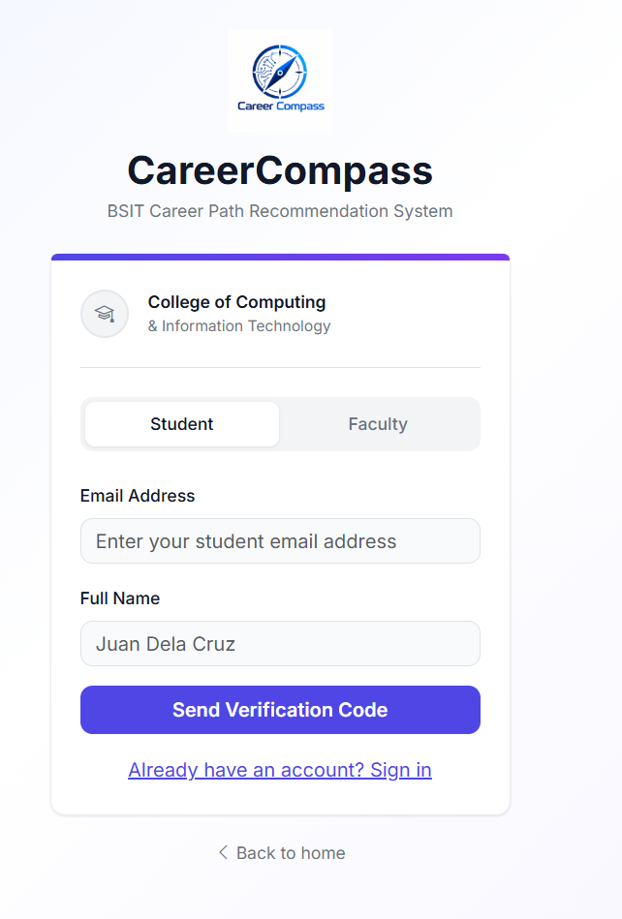
Figure 3.1. Student registration interface
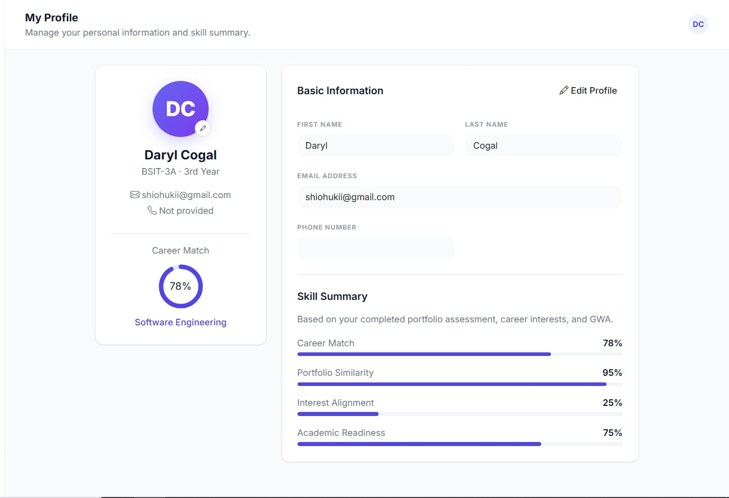
Figure 3.2. Student profile and career-match summary interface

3.2.2 GWA, Career Interests, and E-Portfolio Inputs (SOP 2)
In the career assessment, students enter their GWA (validated against the 1.00 to 5.00 grading scale), rate their interest in each of the five IT career tracks, and submit either a text-based PDF portfolio or a public e-portfolio website URL. Links to social media, video platforms, and private cloud drives are blocked (Figures 3.3 to 3.5).
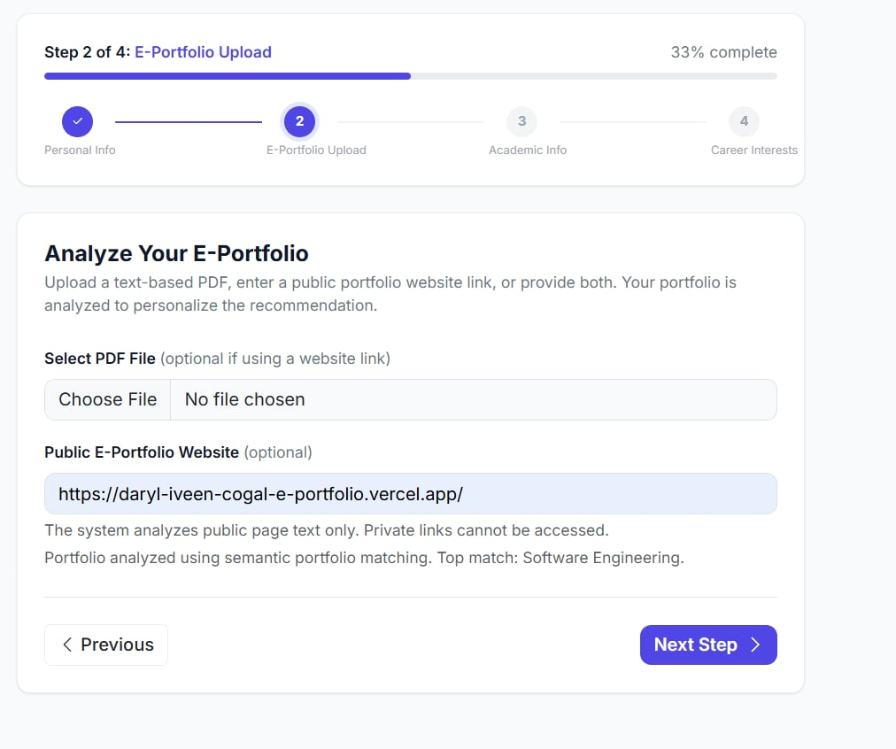
Figure 3.3. E-portfolio upload interface
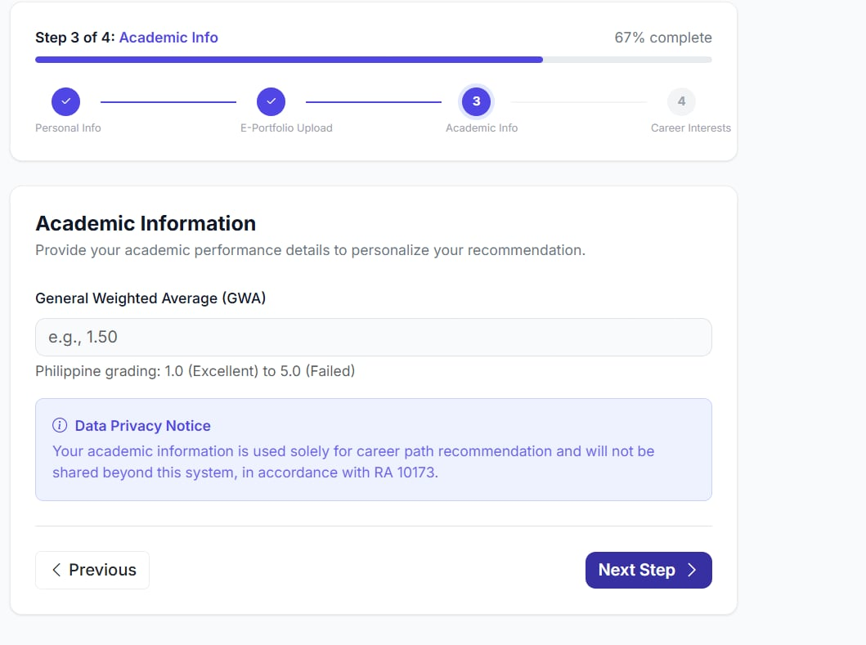
Figure 3.4. Academic information and GWA input interface
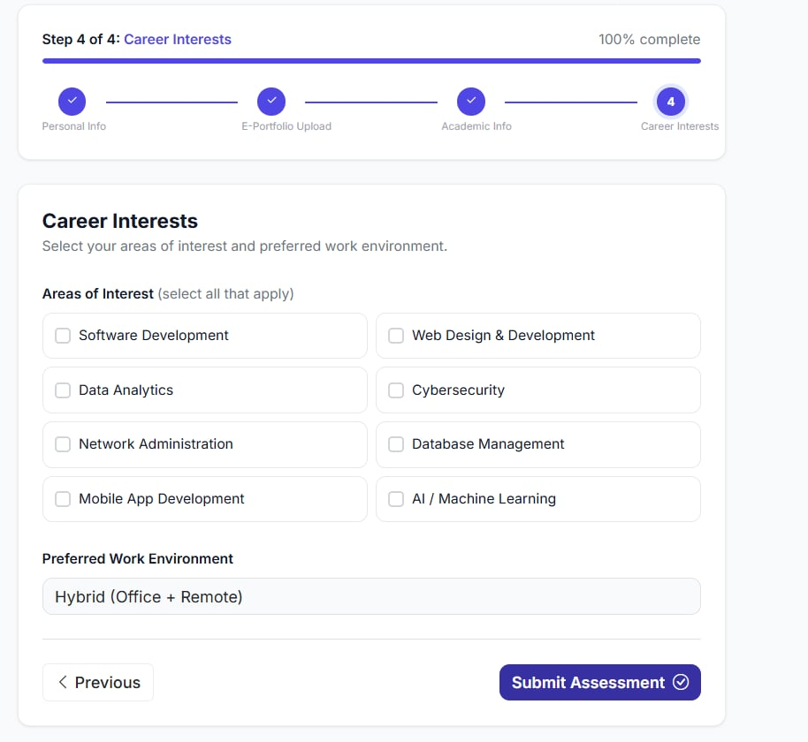
Figure 3.5. Career-interest selection interface

3.2.3 NLP Semantic Matching and Ranked Recommendations (SOP 3)
The recommendation engine processes the extracted portfolio text using the pre-trained all-MiniLM-L6-v2 Sentence-BERT model (Reimers & Gurevych, 2019; Wang et al., 2020) to generate 384-dimensional embeddings. These are compared with predefined descriptions of five IT career tracks (Software Engineering, Web Development, Data Science and Analytics, Cybersecurity, and Network Engineering) using cosine similarity (Rosenberger et al., 2025). The final score is computed as (Portfolio Semantic Similarity × 0.65) + (Career Interest Alignment × 0.20) + (Academic GWA Readiness × 0.15), where the weights are researcher-defined. A keyword-based fallback matcher is used when the semantic model is unavailable. The output is a ranked list of career recommendations with detected skill evidence (Figure 3.6).
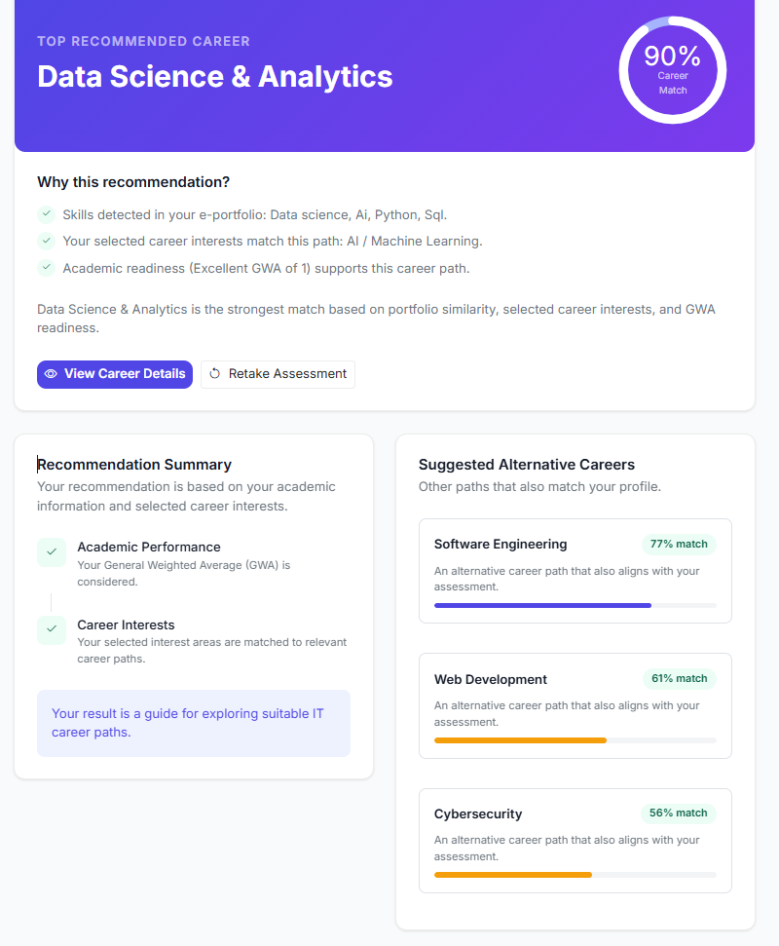
Figure 3.6. Ranked career recommendation output

3.2.4 Dashboards and Reports (SOP 4)
The faculty and administrative dashboard displays total registered students, completed assessments, class-wide career distribution percentages, average match scores, and recently generated recommendations. Faculty members can search student records, review recommendation breakdowns, and record advising notes (Figure 3.7).
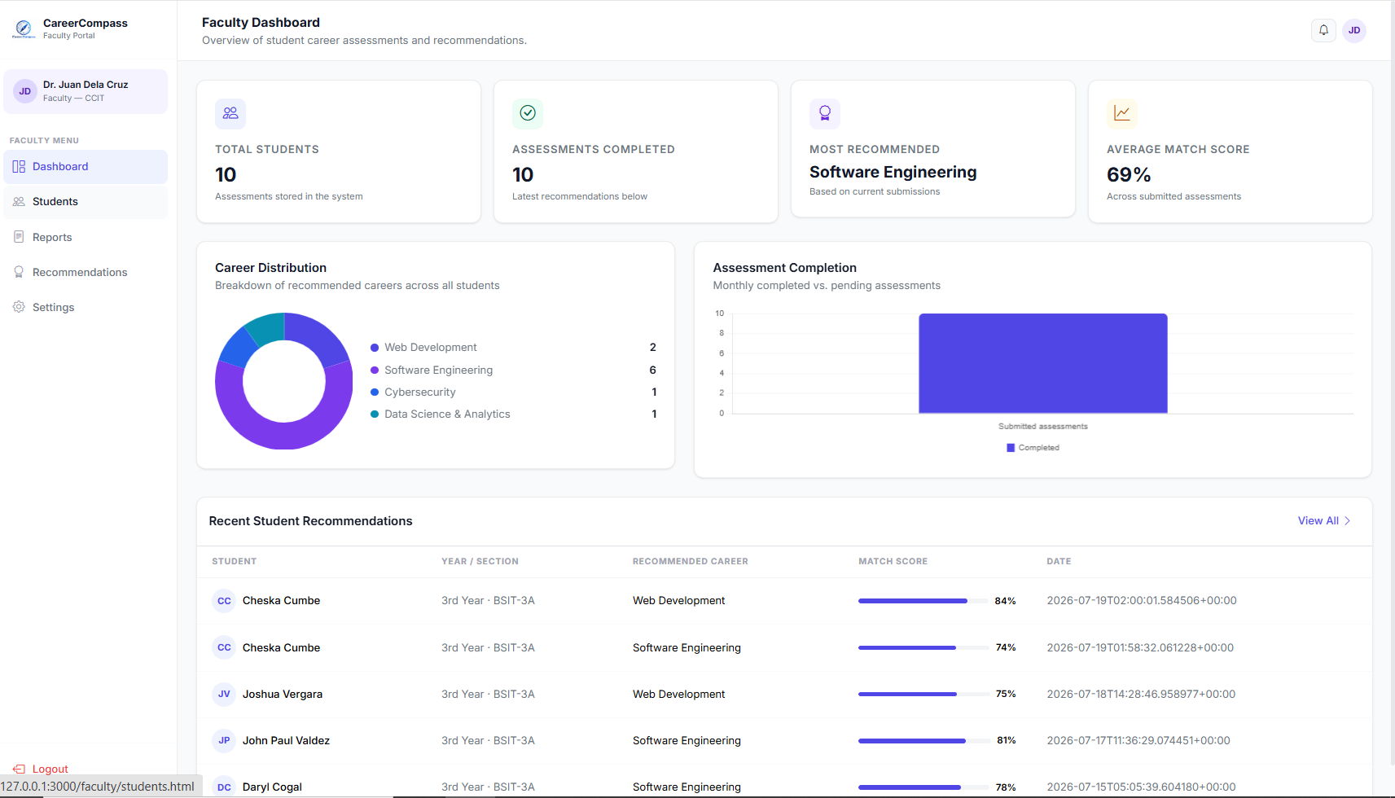
Figure 3.7. Faculty dashboard interface

3.3 Test Plan and Testing Environment
Testing was conducted in a local 64-bit Windows environment. The backend was run on Python 3.14 with the Flask framework and a SQLite database. PDF text extraction used PyMuPDF, web scraping used BeautifulSoup4, and embeddings were generated with the SentenceTransformers library. Table 3.1 lists the test cases executed, and Table 3.2 presents the functional test execution results per module.
Table 3.1. Test Plan Execution Cases
ID | Test case | Expected result | Success evidence
TC-01 | Generate recommendation | The system produces an IT career recommendation based on the entered profile. | Actual output is recorded and compared with the documented expected result.
TC-02 | Check recommendation relevance | The output follows the approved expected recommendation or ranking rule. | Pass when actual output meets the approved rule.
TC-03 | Explore career paths | Possible IT career-path information is displayed. | Result is displayed without an application error.
TC-04 | Complete user task | The task can be completed using the interface and instructions. | Task outcome and any issue are recorded.
TC-05 | Check responsiveness | The request and pages complete during the observed test session. | Observation is recorded.
TC-06 | Repeat recommendation | The system returns the same or documented equivalent result. | Actual outputs are compared and recorded.
TC-07 | Check account access | Authorized access is available and unauthorized access is denied. | Access outcome is recorded.
TC-08 | Collect user evaluation | Completed responses are exported for analysis. | Valid response counts and item ratings are retained in the export.

Table 3.2. Functional Test Plan Execution Results (N = 60 Test Cases per Module)
Functional module | Initial passed | Initial rate | Final pass rate
User Authentication and OTP Mail | 60/60 | 100.0% | 100.0%
Student Profile and GWA | 59/60 | 98.3% | 100.0%
PDF Portfolio Parser | 57/60 | 95.0% | 95.0%
URL Web Scraper | 56/60 | 93.3% | 98.3%
NLP Matching Engine | 57/60 | 95.0% | 100.0%
Student Dashboard | 60/60 | 100.0% | 100.0%

Final pass rates were 100.0% for the user authentication, student profile and GWA, NLP matching engine, and student dashboard modules; 98.3% for the URL web scraper; and 95.0% for the PDF portfolio parser.

3.4 Algorithm Accuracy Results (SOP 3)
The accuracy of the recommendations was evaluated using 60 anonymized student profiles, with 12 profiles per career track. Three (3) IT experts independently assigned a target career track to each profile, and the majority consensus served as the reference label. Table 3.3 presents the resulting confusion matrix, and Table 3.4 presents the precision, recall, and F1-score per track (Grandini et al., 2020).
Table 3.3. Recommendation Classification Matrix (N = 60 Profiles)
IT expert reference track | Software Eng. | Web Dev. | Data Science | Cybersecurity | Network Eng.
Software Eng. (12) | 11 | 1 | 0 | 0 | 0
Web Dev. (12) | 1 | 11 | 0 | 0 | 0
Data Science (12) | 0 | 0 | 12 | 0 | 0
Cybersecurity (12) | 0 | 0 | 0 | 10 | 2
Network Eng. (12) | 0 | 0 | 0 | 1 | 11

Table 3.4. Calculated Performance Metrics per Career Track (N = 60 Profiles)
IT career specialization track | IT expert target cases | Precision | Recall | F1 score
Software Engineering | 12 | 91.7% | 91.7% | 91.7%
Web Development | 12 | 91.7% | 91.7% | 91.7%
Data Science and Analytics | 12 | 100.0% | 100.0% | 100.0%
Cybersecurity | 12 | 90.9% | 83.3% | 87.0%
Network Engineering | 12 | 84.6% | 91.7% | 88.0%
Overall Macro / Weighted Average | 60 | 91.8% | 91.7% | 91.7%

CareerCompass produced 55 correct primary recommendations out of 60 profiles, an overall accuracy of 91.7%, with a macro precision of 91.8%, a macro recall of 91.7%, and a macro F1-score of 91.7%. Data Science and Analytics had no misclassifications (12/12). Five profiles were misclassified: two Cybersecurity profiles as Network Engineering, one Network Engineering profile as Cybersecurity, one Software Engineering profile as Web Development, and one Web Development profile as Software Engineering.

3.5 System Evaluation Results (SOP 5)

3.5.1 Project Testing Results from Student Users
After using the system, BSIT students rated CareerCompass through a 24-item post-use questionnaire administered through Google Forms. The items were grouped into seven domains and rated on a 5-point scale (5 = Strongly Agree to 1 = Strongly Disagree). Of the 70 submissions, 65 student respondents had used the system and are included in the analysis (28 fourth-year, 19 third-year, 16 second-year, and 2 first-year students), yielding 1,544 valid ratings. Mean ratings were interpreted as follows: 4.21 to 5.00 = Very High, 3.41 to 4.20 = High, 2.61 to 3.40 = Moderate, 1.81 to 2.60 = Low, and 1.00 to 1.80 = Very Low. The standard deviation (SD) was computed across all valid ratings in each domain. Table 3.5 and Figure 3.8 present the results. The overall mean rating was 4.62 (SD = 0.55), and domain means ranged from 4.60 (Security) to 4.65 (Overall Acceptability). Of the 1,544 ratings, 1,500 (97.2%) were 4 or 5.
Table 3.5. Student System Evaluation Results by Domain (N = 65)
Evaluation domain | Mean | SD | Verbal interpretation
Functional suitability | 4.62 | 0.55 | Very High
Performance efficiency | 4.61 | 0.55 | Very High
Usability | 4.62 | 0.54 | Very High
Reliability | 4.62 | 0.56 | Very High
Security | 4.60 | 0.55 | Very High
Maintainability | 4.62 | 0.63 | Very High
Overall acceptability | 4.65 | 0.52 | Very High
Overall student evaluation | 4.62 | 0.55 | Very High

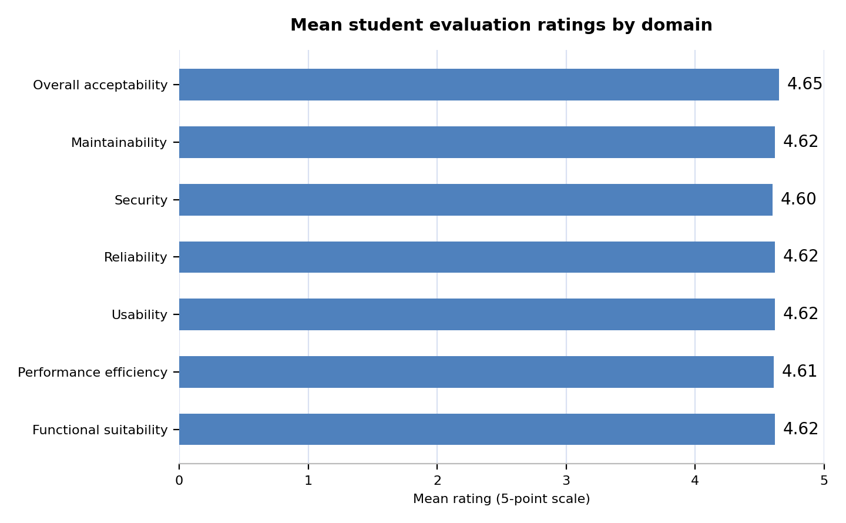
Figure 3.8. Mean student system-evaluation ratings by domain

3.5.2 System Quality Evaluation (ISO/IEC 25010)
After a system demonstration, CareerCompass was evaluated by five (5) respondents, composed of three (3) IT experts and two (2) guidance counselors from the Guidance Office, using the System Evaluation Tool of the College of Computer Studies, Pamantasan ng Lungsod ng Pasig. The tool covers six software quality characteristics aligned with the ISO/IEC 25010 model (ISO/IEC, 2011): functionality, reliability, usability, efficiency, portability, and maintainability. Its 15 criteria were rated on a 4-point scale (4 = Strongly Agree, 3 = Agree, 2 = Disagree, 1 = Strongly Disagree), and mean ratings were interpreted as follows: 3.26 to 4.00 = Strongly Agree, 2.51 to 3.25 = Agree, 1.76 to 2.50 = Disagree, and 1.00 to 1.75 = Strongly Disagree. The SD was computed across all valid ratings in each characteristic (75 ratings in total). Table 3.6 and Figure 3.9 present the results. The overall mean was 3.13 (SD = 0.47), interpreted as Agree. Usability had the highest mean (3.35, SD = 0.81), followed by Functionality (3.20); Reliability, Efficiency, Portability, and Maintainability each had a mean of 3.00. By criterion, Understandability and Learnability had the highest means (3.80 each), and Attractiveness had the lowest (2.20, Disagree). The overall mean was 3.16 among the IT experts and 3.10 among the guidance counselors.
Table 3.6. System Quality Evaluation Results by Characteristic (N = 5)
Quality characteristic | Mean | SD | Verbal interpretation
Functionality | 3.20 | 0.41 | Agree
Reliability | 3.00 | 0.00 | Agree
Usability | 3.35 | 0.81 | Strongly Agree
Efficiency | 3.00 | 0.00 | Agree
Portability | 3.00 | 0.00 | Agree
Maintainability | 3.00 | 0.00 | Agree
Overall system quality | 3.13 | 0.47 | Agree

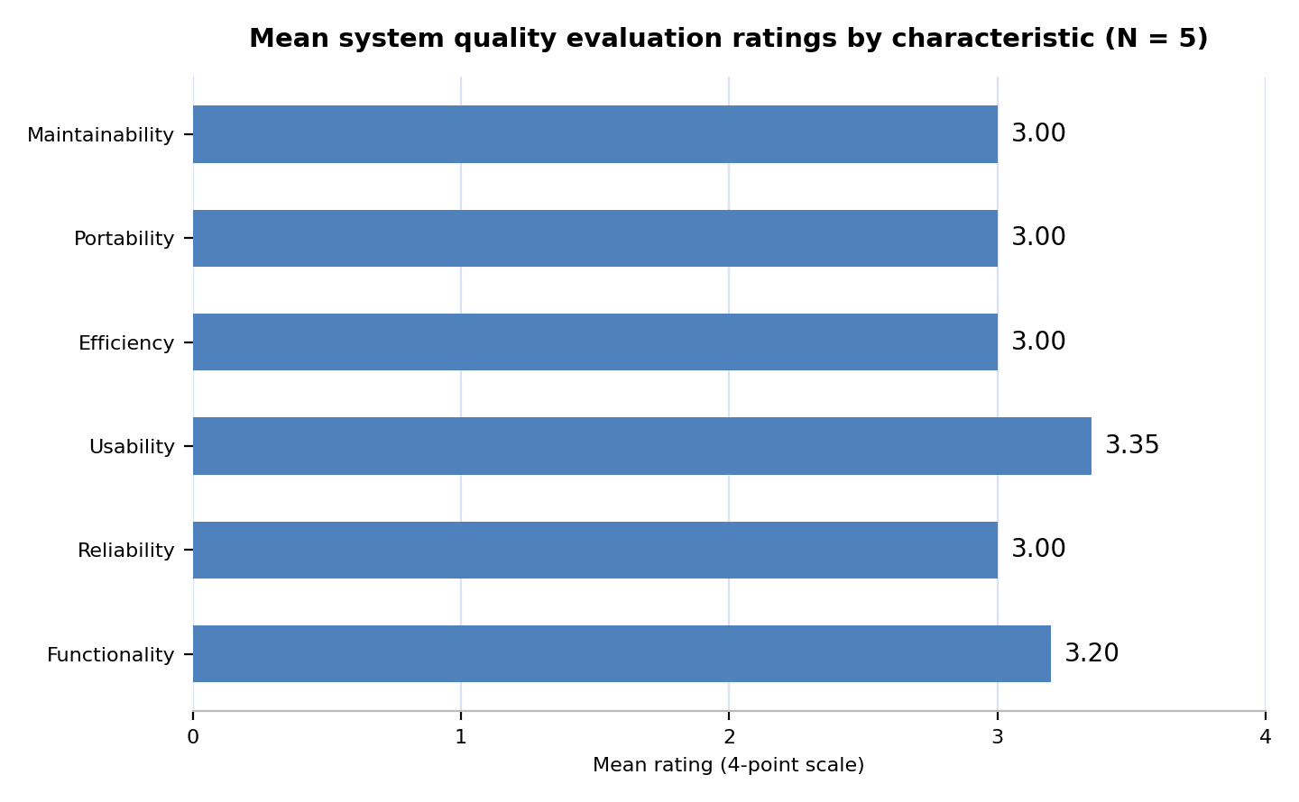
Figure 3.9. Mean system quality evaluation ratings by characteristic
Summary
This chapter presented the results and empirical findings from the development, functional testing, algorithm evaluation, and system quality assessment of CareerCompass: An NLP-Based IT Career Path Recommendation System with E-Portfolio for Bachelor of Science in Information Technology (BSIT) Students of Pamantasan ng Lungsod ng Pasig. To provide a comprehensive assessment of the developed system, the evaluation covered its core functionalities, NLP-based career recommendation performance, student user acceptability, and software quality based on the ISO/IEC 25010-aligned evaluation tool.
The system capabilities were presented in relation to SOP 1 to SOP 4, covering student registration and profile management, GWA and career-interest inputs, e-portfolio submission and text extraction, semantic matching, ranked IT career recommendations, and faculty dashboards and reports. The recommendation engine used the pretrained all-MiniLM-L6-v2 Sentence-BERT model to generate sentence embeddings and compare portfolio content with predefined descriptions of five IT career tracks using cosine similarity. The resulting portfolio similarity score was combined with career-interest alignment and academic GWA readiness using researcher-defined weights of 65%, 20%, and 15%, respectively. This process enabled the system to generate ranked career recommendations based on the information provided by students.
Functional testing was conducted across six system modules: user authentication and OTP mail, student profile and GWA, PDF portfolio parsing, URL web scraping, the NLP matching engine, and the student dashboard. The reported final pass rates ranged from 95.0% to 100.0%. User authentication, student profile and GWA, the NLP matching engine, and the student dashboard achieved final pass rates of 100.0%, while the URL web scraper achieved 98.3% and the PDF portfolio parser achieved 95.0%. These results summarize the observed outcomes of functional testing and identify the modules that may require further improvement.
The recommendation algorithm was evaluated using 60 anonymized student profiles, with 12 profiles assigned to each of the five IT career tracks. Three IT experts independently assigned reference career-track labels, and the majority consensus was used as the reference for comparison with the system's primary recommendations. Based on the reported confusion matrix, CareerCompass produced 55 correct primary recommendations out of 60 profiles, resulting in an overall accuracy of 91.7%, macro precision of 91.8%, macro recall of 91.7%, and macro F1-score of 91.7%. Data Science and Analytics recorded 12 correct recommendations out of 12 reference cases, while the remaining misclassifications occurred between Software Engineering and Web Development, and between Cybersecurity and Network Engineering. These metrics describe the system's agreement with the reference labels used in the evaluation and should not be interpreted as a guarantee of an individual's career success.
Student system acceptability was independently assessed through a 24-item post-use questionnaire. Of the 70 submissions, 65 students who had used the system were included in the analysis, producing 1,544 valid ratings. The overall mean rating was 4.62 (SD = 0.55), interpreted as Very High, while the domain means ranged from 4.60 to 4.65. Furthermore, 1,500 out of 1,544 valid ratings, equivalent to 97.2%, received a rating of 4 or 5. These findings indicate a highly favorable response from participating students regarding their experience with CareerCompass.
Finally, software quality was evaluated by five respondents, comprising three IT experts and two Guidance Office counselors, using the System Evaluation Tool of the College of Computer Studies of Pamantasan ng Lungsod ng Pasig. The tool covered six software quality characteristics aligned with the ISO/IEC 25010 model: functionality, reliability, usability, efficiency, portability, and maintainability. Using a four-point rating scale, the system obtained an overall mean of 3.13 (SD = 0.47), interpreted as Agree. Usability received the highest characteristic mean of 3.35, while Attractiveness received the lowest criterion mean of 2.20, interpreted as Disagree. These results provide a basis for identifying areas for continued improvement, particularly in the visual appeal and presentation of the system.
Chapter 4
Conclusion and Recommendation

Conclusion
The primary purpose of this study was to design, develop, and evaluate CareerCompass: An NLP-Based IT Career Path Recommendation System with E-Portfolio for Bachelor of Science in Information Technology (BSIT) Students of Pamantasan ng Lungsod ng Pasig. The study focused on developing a system that helps BSIT students explore possible IT career paths by considering their academic performance, career interests, and e-portfolio content. The system integrates Natural Language Processing (NLP) through a pretrained Sentence-BERT model to compare portfolio information with predefined descriptions of five IT career tracks: Software Engineering, Web Development, Data Science and Analytics, Cybersecurity, and Network Engineering.
The evaluation covered functional testing of six system modules, algorithm performance testing using 60 student profiles and reference career-track labels, post-use evaluation by 65 student users, and system quality evaluation by three IT experts and two Guidance Office counselors. The results were analyzed in relation to the five Statements of the Problem (SOPs) established in Chapter 1.
Based on the reported findings and evaluation results, the following conclusions were drawn:
Student Profile and Career-Related Factors (SOP 1): CareerCompass was developed to collect and organize the student information needed for career-path recommendations, including year level, academic General Weighted Average (GWA), career interests, and e-portfolio content. These inputs provide the system with information about students' academic performance, stated preferences, and documented skills and experiences. The integration of these factors provides a structured basis for presenting personalized IT career-path recommendations.
Collection and Use of GWA, Career Interests, and E-Portfolio Content (SOP 2): The system provides interfaces for students to enter their GWA, rate their interests across the five IT career tracks, and submit their e-portfolios through supported PDF files or public website URLs. These inputs are processed and incorporated into the recommendation procedure. The inclusion of portfolio information allows the system to consider documented projects, skills, certifications, seminars, and training experiences alongside students' interests and academic performance.
NLP-Based Semantic Matching and Career Recommendations (SOP 3): CareerCompass uses the pretrained all-MiniLM-L6-v2 Sentence-BERT model to generate sentence embeddings and compare portfolio content with predefined descriptions of the five IT career tracks through cosine similarity. The portfolio similarity score is combined with career-interest alignment and GWA using researcher-defined weights of 65%, 20%, and 15%, respectively. Based on the reported confusion matrix for 60 profiles, the system achieved 55 correct primary recommendations, corresponding to an accuracy of 91.7%, with macro precision of 91.8%, macro recall of 91.7%, and macro F1-score of 91.7%. These results describe the system's agreement with the reference career-track labels used in the evaluation. They do not establish that the recommendations predict future career success or guarantee an individual's suitability for a particular profession.
Dashboards and Reports for Career Monitoring (SOP 4): CareerCompass provides student-facing interfaces for reviewing career recommendations and related profile information, together with faculty-facing features intended to support the monitoring of student skills, career readiness, and recommended IT career paths. These features organize relevant information in one system and may support discussions between students, faculty advisers, and the Guidance Office. The system is intended to supplement existing career-guidance activities rather than replace professional counseling or individual career decision-making.
System Acceptability and Software Quality (SOP 5): The student post-use evaluation included 65 students who had used CareerCompass and produced an overall mean rating of 4.62 (SD = 0.55), interpreted as Very High. In the separate system quality evaluation, three IT experts and two Guidance Office counselors evaluated the system using a four-point System Evaluation Tool aligned with the ISO/IEC 25010 software quality model. The system obtained an overall mean rating of 3.13 (SD = 0.47), interpreted as Agree. Usability received the highest characteristic mean of 3.35, while Attractiveness received the lowest criterion mean of 2.20. The results indicate favorable student responses and generally positive expert and counselor evaluations, while also identifying visual appeal as an area requiring improvement.

Recommendations
Based on the conclusions drawn from the findings of the study, the following recommendations are proposed.

Recommendations for Action
- Integration into Career-Guidance Activities: The Guidance Office and faculty advisers may consider using CareerCompass as a supplementary resource during career-exploration sessions for BSIT students. The ranked recommendations may serve as starting points for discussions about students' interests, academic preparation, documented skills, and possible IT career directions. The results should be reviewed alongside students' personal goals and guidance from qualified personnel.
- Student Portfolio Development: BSIT students are encouraged to maintain updated e-portfolios containing relevant projects, technical skills, certifications, seminars, training activities, and other learning experiences. More complete and relevant portfolio information may help the system identify evidence related to different IT career tracks and provide more informative recommendations.
- Orientation for Students and Evaluators: Before using CareerCompass in career-guidance activities, students, faculty advisers, IT experts, and Guidance Office personnel should receive an orientation on the system's features, input requirements, recommendation process, and limitations. Users should understand that match scores indicate relative alignment with predefined career descriptions and should not be interpreted as probabilities of employment or guaranteed career success.

Recommendations for System or Process Improvement
- Improvement of User Interface and Visual Appeal: Future versions should improve the visual design of CareerCompass, particularly the attractiveness and presentation of its interfaces. The system may benefit from more consistent typography, spacing, colors, visual hierarchy, and clearer presentation of recommendation results. These improvements should be evaluated through additional usability testing.
- Enhancement of E-Portfolio Processing: The portfolio-processing component may be improved to support a wider range of document formats and more reliable text extraction. Future development may include optical character recognition (OCR) for scanned documents, clearer error messages for unsupported or unreadable files, and more comprehensive handling of portfolio links. Extracted information should remain traceable to the submitted portfolio so users can review the evidence associated with their recommendations.
- Further Validation of Career-Track Descriptions and Matching Weights: The career-track descriptions and matching weights implemented in CareerCompass should be evaluated further with qualified IT professionals and relevant reference profiles. Future studies may examine whether the current 65% portfolio, 20% interest, and 15% GWA weighting scheme provides appropriate rankings across different student profiles. Any proposed adjustments should be supported by evaluation results rather than assumptions.
- Strengthening of Testing and Data Records: Future system testing should retain organized records of test profiles, expected outputs, actual recommendations, identified errors, corrective actions, and retesting results. Performance testing should also preserve timing logs and testing conditions. Maintaining these records will make the reported functional pass rates, algorithm metrics, and performance measurements easier to reproduce and verify.
- Continuous Improvement of Recommendation Explanations and Reporting: Since CareerCompass already presents recommendation results based on portfolio evidence, interests, and academic information, future improvements should focus on making these explanations clearer and more useful to students and faculty advisers. The system's explanations should remain consistent with the actual inputs and calculations used to generate the career-track rankings, helping users understand the results and identify areas for further learning.

Recommendations for Future Research
- Expanded Validation Using Additional Student Profiles: Future researchers should evaluate CareerCompass using a larger and more diverse set of student profiles. The profiles should be assessed using a clearly documented procedure for assigning reference career-track labels, preferably involving qualified IT experts and a consistent review protocol. This would help determine whether the reported recommendation metrics remain consistent across different student groups and portfolio types.
- Further Validation of Career Recommendations: Future studies should examine agreement between system recommendations and judgments from qualified IT professionals or career-guidance practitioners. Researchers may also investigate how the recommendations compare with students' expressed preferences and subsequent career-development decisions. Longer-term follow-up would be needed before making claims about actual career outcomes.
- Evaluation of Recommendation Weights: Future research may compare the current 65% portfolio, 20% career-interest, and 15% GWA weighting scheme with alternative combinations. Controlled testing should be conducted to determine how changes in the weights affect rankings and agreement with expert reference labels. Any proposed weighting scheme should be supported by documented evaluation results.
- Longitudinal and Broader Institutional Evaluation: Future studies may implement CareerCompass over a longer period and include BSIT students from additional institutions. This could provide information about how students use the system over time, whether recommendations remain relevant as their skills develop, and whether the system can be adapted to different educational contexts.
- Investigation of Additional NLP Approaches: Future researchers may compare the current pretrained Sentence-BERT approach with other semantic-matching models or hybrid methods. Such comparisons should use the same documented test profiles and evaluation procedures. The objective should be to establish whether alternative approaches produce more consistent and relevant recommendations, rather than assuming that a newer or more complex model will automatically perform better.

References
Al-Dossari, H., Abu Nughaymish, F., Al-Qahtani, Z., Alkahlifah, M., & Alqahtani, A. (2020). A machine learning approach to career path choice for information technology graduates. Engineering, Technology & Applied Science Research, 10(6), 6589–6596. https://etasr.com/index.php/ETASR/article/view/3821
Breiman, L., Friedman, J. H., Olshen, R. A., & Stone, C. J. (1984). Classification and regression trees. Wadsworth International Group.
Creswell, J. W., & Creswell, J. D. (2018). Research design: Qualitative, quantitative, and mixed methods approaches (5th ed.). SAGE Publications.
Cui, C. (2024). Career interest assessment: College students career planning based on machine learning. Journal of Electrical Systems, 20(6s), 1633–1644.
Grandini, M., Bagli, E., & Visani, G. (2020). Metrics for multi-class classification: An overview (arXiv:2008.05756). arXiv. https://doi.org/10.48550/arXiv.2008.05756

IEEE Xplore. (2024). Machine learning-based career recommendation system using academic and behavioral analytics. IEEE Conference Publication. https://ieeexplore.ieee.org/document/11495729/
International Labour Organization. (2023). World employment and social outlook: The value of essential work. ILO Publications.
ISO/IEC 25010:2011. Systems and software engineering — Systems and software quality requirements and evaluation (SQuaRE) — System and software quality models. International Organization for Standardization.
LinkedIn Corporation. (2024). Skill Assessments and Career Explorer [Product features]. https://www.linkedin.com/
Lorenzo, G., & Ittelson, J. (2005). An overview of student profile systems. EDUCAUSE Learning Initiative.
National Center for O*NET Development. (2024). O*NET Interest Profiler. U.S. Department of Labor, Employment and Training Administration. https://www.onetcenter.org/IP.html
Powers, D. M. W. (2011). Evaluation: From precision, recall and F-measure to ROC, informedness, markedness and correlation. Journal of Machine Learning Technologies, 2(1), 37–63.
Pressman, R. S., & Maxim, B. R. (2020). Software engineering: A practitioner’s approach (9th ed.). McGraw-Hill Education.
Reimers, N., & Gurevych, I. (2019). Sentence-BERT: Sentence embeddings using Siamese BERT-networks. Proceedings of the 2019 Conference on Empirical Methods in Natural Language Processing (EMNLP-IJCNLP), 3982–3992. https://doi.org/10.18653/v1/D19-1410
Republic Act No. 10173. (2012). Data Privacy Act of 2012. Congress of the Philippines. https://privacy.gov.ph/data-privacy-act/
Ricci, F., Rokach, L., & Shapira, B. (2011). Introduction to recommender systems handbook. In F. Ricci, L. Rokach, B. Shapira, & P. B. Kantor (Eds.), Recommender systems handbook (pp. 1–35). Springer. https://doi.org/10.1007/978-0-387-85820-3_1
Rosenberger, J., Wolfrum, L., Weinzierl, S., Kraus, M., & Zschech, P. (2025). CareerBERT: Matching resumes to ESCO jobs in a shared embedding space for generic job recommendations. Expert Systems with Applications. https://doi.org/10.1016/j.eswa.2025.127043
Schwaber, K., & Sutherland, J. (2020). The Scrum guide: The definitive guide to Scrum. Scrum.org.
Siswipraptini, P. C., Warnars, H. L. H. S., Ramadhan, A., & Budiharto, W. (2024). Personalized career-path recommendation model for information technology students in Indonesia. IEEE Access.
Tosh, D., Light, T. P., Fleming, K., & Haywood, J. (2005). Engagement with electronic portfolios: Challenges from the student perspective. Canadian Journal of Learning and Technology, 31(3).
Wan, Q., & Ye, L. (2022). Career recommendation for college students based on deep learning and machine learning. Scientific Programming, 2022(1), Article 3437139. https://doi.org/10.1155/2022/3437139
Wang, W., Wei, F., Dong, L., Bao, H., Yang, N., & Zhou, M. (2020). MiniLM: Deep self-attention distillation for task-agnostic compression of pre-trained transformers. arXiv. https://doi.org/10.48550/arXiv.2002.10957

